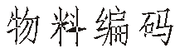





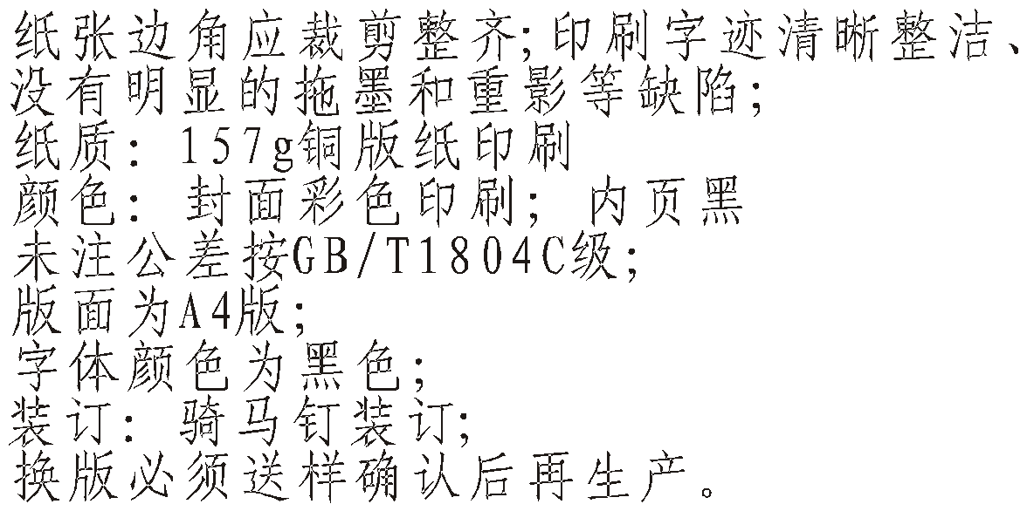

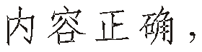





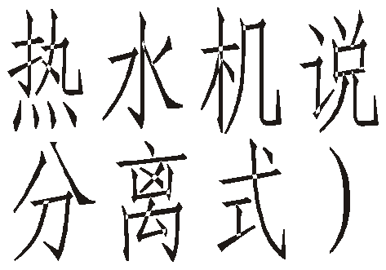

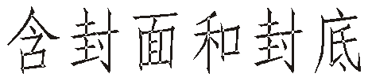



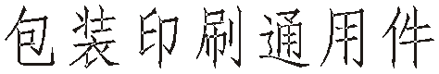

34

|  |  |  |  |  |  |  |  |  |  |
| --- | --- | --- | --- | --- | --- | --- | --- | --- | --- |
|  |  |  | |  |  |  | |  | |
|  |  |  | |  |  |
|  |  |  | |  |  |  | |  |  |
|  |  |  | |  |  |
| 10130010044 |  |
|  |  |
|  |  |  |  |  |  |  | |
|  |  |  |  |  |  |  |  |

MACON

**INSTALLATION & INSTRUCTION**

**MANUAL**

**AIR TO WAT ER**

**HEAT PUMP**

**(EVI MODE)**

Macon Cooling and Heating Energy-efficient Equipment Co., Ltd

**N o t i c e**

1.1 In order to use this product better and safer, please read this instruction care full y befor e insta ll and operate it. Please pay attention to all the notice in operation and maintenance. Save all manuals and doc umen tati on for f utur e reference.

1.2 Air to water pump is a special appliance. Improper installation will cause damage and danger. It should be installed and maintained by the professionals. Please conta ct our authorized loca l service point for installation and maintenance. Please read and follow this instruction carefully before and during ins tallati on. Remarks:

We will not bear the responsibility for any personal injury or unit damage caused by non-Compliance of the regulations and instruction in this manual.

1.3 Please check whether the distribution power capacity, switch and socket

are compliance with the requirements of our unit power. Details please refer to the rating label or parameter table in this manual.

1.4 The power should be equipped with leakage protection separately.

Power cable should be chosen in accordance with the operation requirements of the unit.

1.5 The unit must be grounded safely. Do not use the unit if grounded unsafely.

Do not connect the ground line to the neutral and or tap water pipe.

1.6 The wire must be joined in compliance with the requirements of the wiring chart.

Do not alternate and or repair the unit personally.

1.7 Do not install the unit closed to inflammable, explosive and naked light spot.

1.8 To ensure the unit operate properly, please equipped with a filter in the water input when installation.

**CONTENTS**

**I. Specification................................................................. 1**

1. Model Nomenclature(indoor unit)........................................... 1

2. Model Nomenclature(outdoor unit)......................................... 1

3.Parameter of multi-function air to water heat pump................... 1

4. Installation dimensions of indoor unit................................... 2

5.Installation dimensions of outdoor unit...................................... 2

**II. Installation................................................................... 3**

1. Unit installation position........................................................ 3

2. Installation requirement......................................................... 4

3.Water tank installation select................................................... 4

4.The unit and water tank installation .......................................... 4

5.The refrigerant piping connection for split type unit .................... 5

6.Water pipe connection............................................................. 7

7.Trial operation........................................................................ 8

8. Installation of terminal equipment............................................ 8

9.Installation of the temp detector ............................................... 9

10.Electrical wiring ..................................................................... 9

**III. Use.............................................................................. 11**

1. Function diagram of the remote controller................................ 11

2. Operation and display............................................................ 11

3. System state parameter checking........................................... 14

4. System parameter setting...................................................... 15

5. The maintenance time inquires............................................... 17

6. Date/time/timing on and off settings........................................ 17

7. Lock button/Ddfrost status/Fahrenheit and celsius change....... 18

8. Fault code display................................................................. 18

9. Parameter table.................................................................... 19

**IV. Installation sketch....................................................... 20**

1. Hot water mode installation drawing....................................... 20

2. Heating mode installation drawing ......................................... 21

3. Hot water&Heating or cooling mode installation drawing .......... 22

**V. Maintenance and repair................................................ 23**

1. Malfunction Indicating Table.................................................. 23

**VI. Wiring diagram ........................................................... 24**

1. Mk3092 PCB input and output port definition ........................... 24

2.The electrical box of internal structure .................................... 25

3.MK3077 Power protection board setting.................................. 27

4.Unit wiring diagram ............................................................... 28

**I. Specification**

**1. Model Nomenclature(indoor unit)**

MA CHR W S W A /P S(B 01 D)

Source medium

MD: Dual source

(air source +ground source) MA: Air source

MW: Ground source Function of the unit C: Air co oling

R: Air he ating

CH: Air cooling and hot water CR: Air cooling and heating HR: Hot water

CHR: Air (heating+cooling) and hot water

Energy exchange medium

A: Refrigerant W: Water S:with solar

(Without solar omitted)

The figure represents the horse power of unit eg:010 means 1 horse power

**2. Model Nomenclature(outdoor unit)**

MA FP A ( )

D:With electrical heating

(Without electrical heating omitted)

Design serial number

B: Inverter

E: EVI

(Without inverter or EVI omitted) S:3phase (single phase omitted)

P:With built in pump

(Without built in pump omitted)

A: Horizontal fan direction B: Upward fan direction C:Double air duct type

(Omit the split type unit model)

Z: Integrated type

W: Split type(indoor unit )

Energy exchange medium

MA: Refrigerant

MW: Water

FP: Fan coil

**3.Parameter of double source heat pump**

Design alternative serial number

A: Horizontal fan direction

B: Upward fan direction

The figure represents the horse power of unit eg:010 means 1 horse power

|  |  |  |  |  |  |
| --- | --- | --- | --- | --- | --- |
| Indoor unit model | MACHRW(S) | 050W/(E01) | 050W/S(E01) | 080W/S(E01) | 100W/S(E01) |
| Outdoor unit(Side fan) mode | MAFP | 050A | 050A | 080A | 100A |
| Rated Cooling Capacity | kW | 13.0 | 13.0 | 20.8 | 26.0 |
| BTU/h | 44400 | 44400 | 71000 | 88800 |
| Rated Input Power(Cooling) | kW | 4.33 | 4.33 | 6.93 | 8.67 |
| Rated Input Current(Cooling) | A | 19.7 | 6.6 | 10.6 | 13.2 |
| Rated Heating Capacity | kW | 15.0 | 15.0 | 24.0 | 30.0 |
| BTU/h | 51200 | 51200 | 81900 | 102400 |
| Rated Input Power(Heating) | kW | 4.80 | 4.80 | 7.70 | 9.60 |
| Rated Input Current(Heating) | A | 21.9 | 7.5 | 12.0 | 15.0 |
| Electrical heating | kW | 4.0 | 4.0 | 4.0 | 4.0 |
| Rated Input Current | A | 19.0 | 19.0 | 19.0 | 19.0 |
| Rated Output Water | L/h | 380 | 380 | 600 | 750 |
| Power Supply | V/PH/Hz | 220/1/50 | 380/3/50 | 380/3/50 | 380/3/50 |
| Compressor |  | Scroll | Scroll | Scroll | Scroll |
| Compressor Qty |  | 1 | 1 | 1 | 1 |
| Fan Qty |  | 2 | 2 | 2 | 2 |
| Noise | dB(A) | 58 | 58 | 60 | 60 |
| Refrigerant Liquid Pipe | inch | 1/2 | 1/2 | 5/8 | 5/8 |
| Refrigerant Gas Pipe | inch | 5/8 | 5/8 | 7/8 | 7/8 |
| Refrigerant Gas Type |  | R410A/R407C | | | |
| Water Connection | inch | 1 | 1 | 1-1/4 | 1-1/4 |
| Water Flow Volume | m3/ h | 4.0 | 4.0 | 6.0 | 7.0 |
| Indoor Unit Net Dimensions(L/W/H) | mm | 670/600/760 | 670/600/760 | 1230/730/800 | 1230/730/800 |
| Indoor Unit Shipping Dimensions(L/W/H) | mm | 730/650/810 | 710/670/780 | 1280/760/840 | 1280/760/840 |
| Outdoor Unit Net Dimensions(L/W/H) | mm | 730/650/810 | 930/440/1270 | 1105/470/1540 | 1105/470/1540 |
| Outdoor Unit Shipping Dimensions(L/W/H) | mm | 1080/480/1310 | 1050/450/1310 | 1145/500/1580 | 1145/500/1580 |
| Indoor Unit (Net/Shipping)Weight | kg | 145/160 | 145/160 | 200/230 | 200/230 |
| Outdoor Unit (Net/Shipping)Weight | kg | 60/65 | 60/65 | 65/75 | 65/75 |

Note: (1)The manual is a technical parameters measured in the following conditions: outdoor dry temperature is 7 and wet bulb temperature is 6 ,the temperature of water inflow is 15 and of water outflow is 55 .

(2)Using in ambient temperature:-25 45

**4.Installation dimensions of indoor unit**

Units: mm

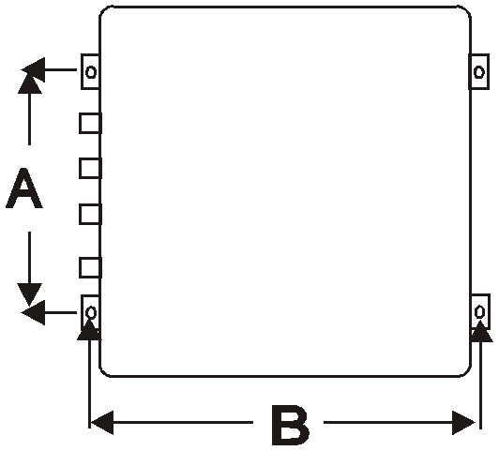

|  |  |
| --- | --- |
| **MODEL**  **Size** | MACHRW050(E01) MACHRW050/S(E01) |
| A | 450 |
| B | 640 |

B

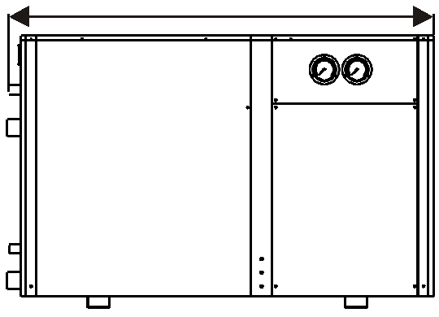

G

Units: mm

|  |  |  |
| --- | --- | --- |
| **Size MACHRW** | 100W/S(E01) | Meaning |
| A | 800 | High |
| B | 1230 | Length |
| C | 730 | Wide |
| D | 750 |  |
| E | 710 |  |
| F | 4- 12 | Mounting hole |
| G | 1-1/4 | Hot water outlet |
| H | 1-1/4 | Hot water inlet |

A H

C

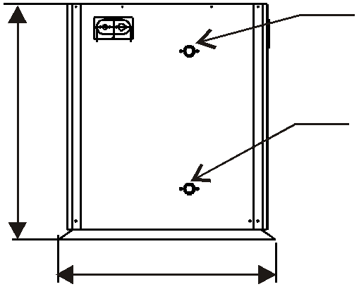

E

D F

**5.Installation dimensions of outdoor unit**

Units: mm

|  |  |
| --- | --- |
| **MODEL**  **Size** | MAFP060A MAFP040A |
| A | 525 |
| B | 440 |

A B

Units: mm

|  |  |  |
| --- | --- | --- |
| **Size MAFP** | 080A 100A | Meaning |
| A | 1540 | High |
| B | 1105 | Length |
| C | 470 | Wide |
| D | 725 |  |
| E | 485 |  |
| F | 4- 12 | Mounting hole |

A

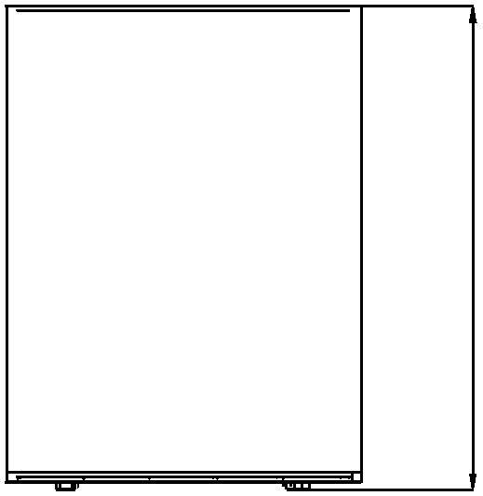



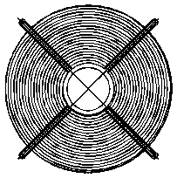

D F

E C

|  |  |  |  |  |
| --- | --- | --- | --- | --- |
|  |  | | | |
|  |  |  |  |

|  |  |  |  |  |  |  |
| --- | --- | --- | --- | --- | --- | --- |
|  |  |  |  |  |  |  |
|  | B | | | | |  |

**II. Installation**

**1. Unit installation position**

To avoid ventilation short, the r unit discharged air should not return when installation. Please keep enough space around the unit for repair. Right and wrong means as below:

MACON

|  |  |
| --- | --- |
| Wrong | Right |
|  |  |
|  |  |
|  |  |

Notice:

1. To get enough air for ventilation of the unit, the installation position should be with good ventilation.

2. The installation position can hold the outdoor unit without noise and shake.

3. No sunlight to the unit. Set an awning if necessary.

4. The water from rain and defrosting can be discharged in the installation position.

5. The unit will not be covered by snow in the installation position.

6. The discharged air will not face strong air in the installation position.

7. Assure the noise caused by the unit ventilation and operation will not affect the neighbour.

8. The installation position will not be affected by garbage, oil and mist.

9. The unit will be damaged under the condition with oil(engine oil), salt(sea area)

and sulfide air(near thermal spring and refining factory).

**2. Installation requirement**

2.1 The unit can be installed in the balcony, roof, floor or any other convenient place and reliable load-bearing.

2.2 Airiness place.

2.3 No heat radiation or other heat source place

2.4 Should be set up shed against the snow in winter.

2.5 Barrier-free at the air inlet or outlet place.

2.6 Outlet against strong winds blowing place.

2.7 There should be drainage channels around the machine in order to rule out the condensate.

2.8 Control Panel, do not install in the bathroom, so as not to affect the unit work by wet.

2.9 Should leave enough space around the machine. As shown below.

**A. Side fan type installation space requirements:**

500mm

600mm

Air intlet

300mm

Unit

1500mm

Air outlet

200mm

600mm

200mm

500mm

|  |  |  |
| --- | --- | --- |
|  | |  |
|  |  |  |

Unit

|  |  |  |
| --- | --- | --- |
|  | |  |
|  |  |  |

600mm

Unit

|  |  |  |
| --- | --- | --- |
|  | |  |
|  |  |  |

Bolt

fix

Bolt

fix

200mm

**B. Top fan type installation space requirements:**

2000mm

600mm

|  |  |  |  |  |
| --- | --- | --- | --- | --- |
|  |  |  |  |  |
|  | | | | |
|  |  |  |  |  |

700mm

400mm

700mm

400mm

|  |  |  |  |  |
| --- | --- | --- | --- | --- |
|  | | | | |
|  |  |  |  |  |

400mm

Bolt fix

1000mm

1000mm

**3.hot water tank and buffer tank install location select**

3.1 The water tank can be installed in the outdoor with heat pump outdoor unit, such as balconies, roofs, floors, also can be installed in the room.

3.2 Water tank must be standing install, the installation place is a solid foundation, must be bear the weight of the tank when full of water.

3.3 Around the water tank , as well as water pipes and hot water pipes should install a valve.

3.4 Do not install the water tank, where exist pollute and corrosive gases.

**4.The unit and water tank installation**

**4**.1 Unit install base is concrete structures, also can be made of steel angle brackets, plus vibration rubber pad placed on the ground or roof, to ensure the unit horizontally.

4.2 Installed base design should in accordance with units and water tanks installed size

And operational quality.

4.3 Directly use expansion bolts to fix unit and water tank to the concrete base.

4.4 Around the unit and tank should be drain or outlet.

**5. The refrigerant piping connection for split type unit**

**5.1** Each component's names and function of refrigerant stop valve

Adapter connector



The connecting pipe joint of indoor unit and

Indoor unit and outdoor unit copper connecting pipe

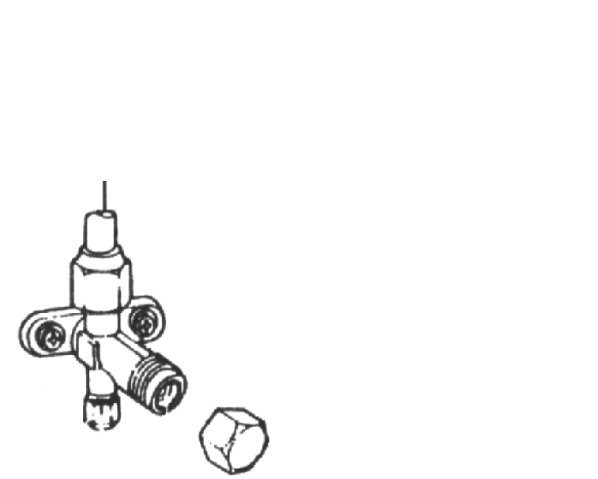

outdoor unit . Needle valve



To discharge the air in the connecting pipe

and outdoor unit by refrigerant pressure or connect a vacuum pump.

Valve plug



Turn on or turn off the stop valves.

Adapter connector

Needle valve

Needle valve nut

**Stop Valves**

Adapter connector nut

valve plug

valve plug nut

**5.2** The unit refrigerant pipe connecting

**A:** According to the indoor and outdoor unit fixed location and location of holes through the wall, choose a good direction lead to pipe. Then begin the indoor pipe connection work.

**B:** Use a wrench to remove the adapter

connector nut;

**C:** As shown on the right, press the trumpet on the connector cone, then hold the connection pipe

Connecting pipe

Copper pipe

Flare nut

Adapter connector

Copper pipe

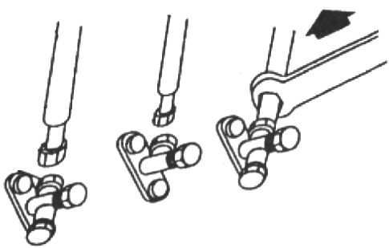

with one hand, so that keep the connector axis in the first line, the other hand the gradually screw the flare nut on the connector, then tighten with wrench.

**5.3** Air discharge ( by indoor unit refrigerant)

Low pressure valve

High pressure valve

If the system is small, use refrigerant empty way to discharge the pipe and outdoor unit air,

to discharge the air in the connecting pipe and outdoor unit, when there's refrigerant in the pipes originally, just open the low pressure side needle valve of indoor unit to discharge the air by refrigerant pressure. **As the following steps:**

**A:** Unscrew the valve plug nut on the stop valve , and unscrew the needle nut on the indoor unit low pressure side.

**B:** Open the stop valve at outdoor unit high/low pressure side by valve plug.

**C:** Open the stop valve at indoor unit's high pressure side by valve plug, Note: don't open the one at low pressure side.

**D:** Open the needle valve by small screwdriver , and this outlet will discharge the air in connecting pipe and outdoor unit at the same time.

**E:** Close the needle valve after open it about 10-20 seconds ,The time is according to the size of outdoor unit and the length of the connecting pipe.

**F:** After the air discharging, open the stop valve at the indoor unit low pressure side

**G:** Screw and close the screw cap on the stop valve

**As the picture show**

Big pipe

1

Small pipe

Low pressure side

High pressure side

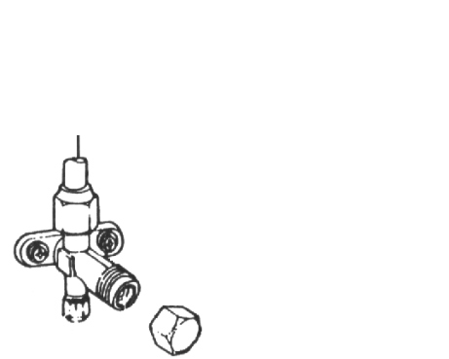







Low pressure side

High pressure side

valve plug

valve plug

valve plug

valve plug

Needle valve

Needle valve

Needle valve

Needle valve

2

valve plug nut

valve plug nut

**Indoor unit Outdoor unit**

NOTE 1 : The direction of the arrow is the air discharging flow direction which is same as the refrigerant flow direction. NOTE 2 : The air is discharged from this outlet

**5.4** Air discharge ( by vacuum pump)

If the system large or after maintenance of outdoor system, should use the vacuum pump discharge way to empty the air and water within the system.

**As the following steps:**

**A:** As the picture show, connect the vacuum pump with the pressure gauge, and then connect the vacuumed connecting pipe with the needle valve on the indoor unit low pressure side.

Outdoor unit

**B:** Unscrew the valve plug nut on the stop valve , and unscrew the needle nut on the indoor unit low pressure side.

**C:** Open the stop valve at outdoor unit high/low pressure side by valve plug.

Note: Do not open the indoor unit high/low

pressure side stop valve.

High pressu

Stop valve

Low pressure side

|  |  |  |  |  |
| --- | --- | --- | --- | --- |
| re sid | e |  | | |
|  |  | |  |
|  |  |  |  |  |
|  | | | |

Stop valve

Hose

|  |  |
| --- | --- |
|  |  |
|  |  |
|  |  |

**D:** Open the compound pressure gauge and vacuum pump to vacuum the outdoor unit and pipe, so that the absolute pressure not higher than 130Pa, and keep the pressure does not rise within 5 minutes after vacuum.

**E:** After the air discharging(vacuumming),disconnect the connecting between the pressure gauge and indoor unit stop valve .

**F:** Open the stop valve at indoor unit high/low pressure

side by valve plug, then let the indoor unit's refrigerant

Indoor unit

Composite table

Vacuum pump

flow in outdoor unit(if need to add more refrigerant, please refer to 2.4).

**5.5** Add refrigerant

When the pipe is too long, please add

ad dit ion al refrigerant as following formula: Additional refrigerant amo un t=

(one-way tube length -5) x (0.015~0.02) kg, choose 0.015 or 0.02 according to the size

of diameter.

High pressure

Outdoor unit

Low pressure side

R ef rig er an t

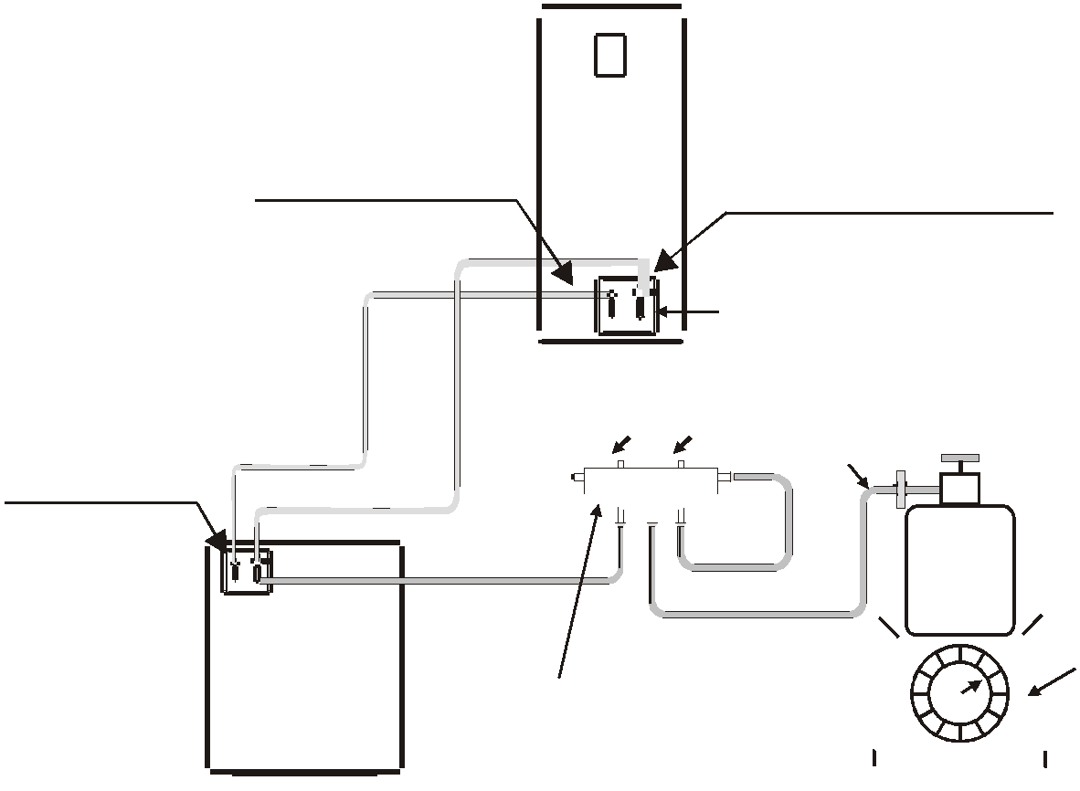

choose 0.015;

when the diameter = 15.88, choose 0.02 . The methods to add refrigerant

refer to the right diagram :

**5.6** Leak check

Stop valve

Indoor unit

Composite table

Scale

After discharge the air, use electronic leak detector or soapy water to test all the connectors in the indoor and outdoor unit.

**6. Water pipe connections**

**6.1** Pipe should be a kind of pipe that heat-resistant,rust-proof, uneasy-fouling.and in co nfor mity w ith national health and safety standards, which can be stainless steel pipe, co pper pi pe, al umi num water pipe, hot water PPR pipes and so on.

**6.2** Water tank outlet pipe and overflow pipe is better to installed around the gutter or sewer, so that to convenient to drainage.

**6.3** The connection of the heat pump unit and water tank must be installed a stop valve or dismountable loose joint, for maintenance use.

**6.4** Water pipes are arranged reasonably to minimize bending and reduce the pressure loss of water system .

**6.5** The connection of tap water pipe and water filling connection must install one-way valve, f ilter, supply water solenoid valve (for tank-type water tank) and pressure relief devices

(for close-type valve the parameter value is 0.7MPa), installed when valve body arrow is same as with the flow direction to prevent water block. The cycle water outlet of the heat pump unit should connect to the inlet of water tank , The cycle water inlet of the heat pump unit should connect to the outlet of water tank, the water supply inlet of the tank should connect to the heat water supply outlet . The entire piping system should be clean,

no rust and dirt residue to prevent pipe blockage.

**6.6** After the installation of the water filling pipe and cycle water pipe and hot water supply pi pe , all the pipes should take the water tightness test. And ensure that the system is clean. And then cover insulation on the pipe and valve (including the supply water pipes and valves).

**6.7** Power line and signal line layout should be neat, rational, strong and weak lines separating cable and Can not interfere with each other, without contact with the connecting pipe and valve.

**6.8** After the construction of all wiring is completed, carefully check the correct order to connect the power.

**6.9** Unit electric wire connection: connect to the appropriate terminals according to wiring diagram, and fix it by the pressure line of board in the electrical box.

**6.10** All the wiring construction is completed, can be plugged in only after careful examination correctly.

**6.11** Unit control board fuse parameters: 5A/220V.

**6.12** The unit wire controller must be fixed in the bottom of standard electrical switch box.

**7. Trial operation(should be operated by professionals)**

**7.1** Check before trial operation

**A:** Check the pipe system. Check the whole pipe system. Ensure the water volume in the system is full and the air is exhaus ted complet ely. Check whether the valve is open throughout the system and the thermal insulating of the pipe is well.

**B:** Check the power supply and distribution system. Check whether the power supply voltage is normal, the power distribution accessory screws all tighten, supply power is in compliance with the wiring diagram and the wire is grounded well.

**C:** Check the air cooled water chiller. Check whether any screw loose. Check the signal indicator light (green) of the outdoor unit control panel is illuminated normally and the fault indicating lamp(red) is illuminated. Connect the pressure gauge to the freon feed mouth for checking the pressure during operation. Disconnect them after test is ok.

**7.2** Trial operation

**A:** Press on/off in the remote controller turn on the hot water circulating pump whether t he water pump operates normally. Observe and determine whether air pipe is exhausted completely, flow switch is closed, hydraulic pressure indicated in the pressure gauge is more than 0.2MPa.Come to next step after confirm the circulating water system works normally.

**B:** Press on/off in the remote controller, the water pump and fan start immediately.

The compressor start after the unit operates for some time. Observe and determine if there's any abnormal sound during operation. Stop to check the unit if there's abnormal sound. The unit can continue to run only when there's no abnormal sound. Check whether the cooling system pressure is normal at the same time.

**C:** Check whether the input power and current of the unit are compliance with the parameter in this Instruction. If not, stop to check the unit.

**D:** Observe whether the outlet water temperature is normal.

**E:** Parameter of the remote controller has been set before leave of the factory. Never alternate them personally.

**8. Installation of terminal equipment**

8.1 Indoor terminal equipment installation (such as: fan coil, radiator heater or floor heating), the equipment should be installed in accordance with relevant regulatory requirements.

8.2 In accordance with the requirements of engineering design drawings, installation and construction.

8.3 Use a soft connector to connect the unit and fan coil inlet and outlet pipes; install fan coil condensate drain pipe, connect the condensate drain interface, and to ensure smooth drainage of condensate water.

9 . I n s t a l l a t i o n o f t h e t e m p d e t e c t o r

D e t e c t o r

Ta n k

D e t e c t o r

Ta n k Ta n k Ta n k

D e t e c t o r D e t e c t o r

T h e h e a d

T h e h e a d o f s e n s o r

c o n d u c t i o n s i l i c a g e l

T h e h e a d o f s e n s o r

< 5 p i n

T h e h e a t

c o n d u c t i o n

s i l i c a g e l

o f s e n s o r

< 5 p i n

< 5 p i n

T h e h e a t

c o n d u c t i o n

s i l i c a g e l

The first step The second step The third step The fourth step

9.1.The first step Daub the heat conduction silica gel spreads in the front of sensor, and insert into the detector.

9.2.The second step use < 5 pin to push the detector into the end of the detector against the end of the sensor, and marks on level of the pin and the detector.

9.3 The third step putout the pin the position of mark to be at the same level with the inlet of detector check whether the sensor is inserted to the pipe terminal.

9.4 The fourth step the inlet of the detector is sealed with the glass silica gel, and keep the inlet

of the detector upwards and uprightness about an hour.

**10. Electrical wiring**

10.1 The unit should use dedicated power supply, power supply voltage line corresponding with rated voltage.

10.2 The unit power cable must use copper cable, the cable diameter must ensure that the unit's maximum starting current requirements.

10.3 The unit power supply circuit must have a grounding wire, which should connect with a reliable external ground wire, and the external ground wire is effective.

10.4 Wiring construction must be installed by professional technicians refer to circuit diagram.

10.5 Power lines and signal line layout should be neat, rational, strong and weak lines separate and can not interfere with each other, while not contacted with the connecting pipe and the valve body.

10.6 When power lines and control lines parallel, the wires were placed in each tube, also leave appropriate distance between the lines.

10.7 Unit electric wire connection: take the unit power line, remote control three core lines, electric heater power line, solar circulated water pump control power line, water tank temperature sensing line, solar collector temperature sensor line, terminal equipments connect to unit lines, through the unit wiring hole set into the electrical box, connect to the appropriate terminals according to wiring diagram, and fix it by the pressure line of board in the electrical box.

10.8 Unit control panel Code Mk3092, Fuse specifications: 5A/250V

10.9 Power wiring as follows (single unit):

A:Heat pump unit power input

L N R S T N





**Ground line**

**Zero line**

**Phase line 3**

**Phase line 2**

**Phase line 1**

**Ground line**

**Zero line**

**Phase line**

|  |  |  |  |  |  |  |  |  |
| --- | --- | --- | --- | --- | --- | --- | --- | --- |
| **Mode** | **Host Power** | **Phase line** | **Zero line** | **Ground line** | **Max.line length (m)** | **Signal line** | **Tem. sensor assistance line** | **Max.line length (m)** |
| 050W(E01) | 220V/1PH/50Hz | 6.0mm2 | 6.0mm2 | 6.0mm2 | 15 | 0.5mm2 | 0.5mm2 | 50 |
| 050W/S(E01) | 380V/3PH/50Hz | 4.0mm2 | 4.0mm2 | 4.0mm2 | 15 | 0.5mm2 | 0.5mm2 | 50 |
| 080W/S(E01) | 380V/3PH/50Hz | 6.0mm2 | 6.0mm2 | 6.0mm2 | 15 | 0.5mm2 | 0.5mm2 | 50 |
| 100W/S(E01) | 380V/3PH/50Hz | 6.0mm2 | 6.0mm2 | 6.0mm2 | 15 | 0.5mm2 | 0.5mm2 | 50 |

B:Auxiliary electric heater power input

|  |  |  |  |  |  |  |  |  |
| --- | --- | --- | --- | --- | --- | --- | --- | --- |
| **Mode** | **Host Power** | **Phase line** | **Zero line** | **Ground line** | **Max.line length (m)** | **Signal line** | **Tem. sensor assistance line** | **Max.line length (m)** |
| 0.40Kw | 220V/1PH/50Hz | 4.0mm2 | 4.0mm2 | 4.0mm2 | 15 | 0.5mm2 | 0.5mm2 | 50 |
| 0.75Kw | 220V/1PH/50Hz | 8.0mm2 | 8.0mm2 | 8.0mm2 | 15 | 0.5mm2 | 0.5mm2 | 50 |

Note:

1. used PVC insulated copper wire for above wiring

2. for installation requires, the line is longer than the maximum line length, please contact the company

**III. USE**

**1. Remote controller interface displays as below**

Prg

Ese

Welcome to use

**2. Operation and display**

|  |  |  |
| --- | --- | --- |
|  | UNIT  ON/OFF | Press this button to control the unit's  ON or OFF |
| Prg | SET | Press this button to enter the main menu interface |
| Ese | BACK | Press this button to return to the previous  screen |
|  | UP | Modify theparameter values or turn to next page |
|  | DOWN | Modification parameter values or turn to next page |
|  | ENTER | Press this button and enter the next parameters interface or enter parameters modification state, and confirm the modification |

2.1 . Power on(off)/mode display status

MODE

Off

MODE

Hot water

|  |  |  |  |  |  |
| --- | --- | --- | --- | --- | --- |
|  | A.C. water Inlet | 12 |  | A.C. water Inlet | 12 |
| Prg | Hot water tank | 25 | Prg | Hot water tank | 25 |
|  | Solar Collector | 25 |  | Solar Collector | 25 |
| Ambient temp. 30 Ambient temp. 30  Ese 2013-04-08 11:25 Ese 2013-04-08 11:25 | | | | | |

**Power off**

**Power on**

2.2 Mode of operation

Under the main interface,press:

Prg

enter into parameter setting interface,choose

"main menu ",press button,choose "Mode select",press into the mode setting, press to view and choose,press again to go into the modify parameter interface, the corresponding parameter value is flashing,press to modify the value,press

Ese

(E.g)

eturn to the previous menu.

Prg

Ese

MODE

Hot water tank

Solar Collector

2013-04-08 11:25

Off

25

25

Prg

Ese

Main menu

Maintenance

Water supply setting Prg

Ese

Mode select

Unit status

Press

Prg

button

Press

button

Press button you can change the running mode

Press button you can change the set heating temp.

|  |  |  |  |  |  |  |  |  |  |
| --- | --- | --- | --- | --- | --- | --- | --- | --- | --- |
| Mode | | Heating  Hot water | | Press | button you can |  | Mode | Heating  Hot water | |
| A.C.heat temp. 38 A.C.heat temp. 38 | | | | | | | | | |
|  |  | |  |  |  |  |  | |  |
|  | Aux.heating | | on | Press | button you can turn on/off |  | Aux.heating | | on |
| Ese Priority A.C/H.W auxiliary electric heater Ese Priority A.C/H.W | | | | | | | | | |

Press button again

Prg

Hot water temp. 55

change the set hot water temp.

Prg

Hot water temp. 55

Press button you can choose the priority of air condition or hot water.

2.3 Mode introduction

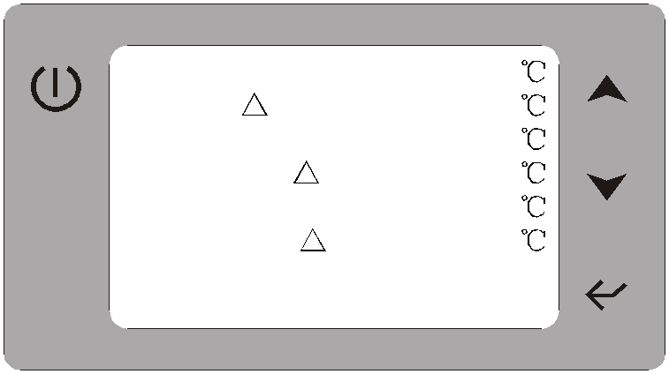

There are six selection modes, the following is the mode of display and introduction

Cooling mode



|  |  |  |  |  |  |
| --- | --- | --- | --- | --- | --- |
| Mode | Cooling | 1.1 Hot water temp. | 55 | 4.1 Power memory | On |
|  |  | 1.2 H.W T | 5 | 4.2 Economic mode | Off |
| A.C. cool temp. | 12 | 1.3 Heating temp. | 40 | 4.3 H.W.pump | Normal |
|  |  |  |  |  |  |
|  | |  |  | | |

|  |  |  |  |  |  |
| --- | --- | --- | --- | --- | --- |
| Prg Prg | | 1.4 Heating T  1.5 Cooling temp. | 5  12 | Prg | 4.4 EVI valve 5  4.5 Comp.PT temp. 105 |
| Ese | Ese | 1.6 Cooling T | 5 | Ese | 4.6 E.H.H.W.pump Special  4.7 Cooling mode Off  4.8 Elec.mode Heat&H.W |

The parameter setting of cooling mode

1.Parameter 1.5 under air condition side cooling mode,the setting of water inlet temperature .

2.Parameter1.6 under air condition side cooling mode,the compressor restart difference temperature.

3.Parameter4.7 whether open the cooling function to the user interface

On:open Off: don t open

Heatling mode



Prg

Ese

Aux. Heating

Off

Prg

Ese

1.4 Heating T 5

1.5 Cooling temp. 12

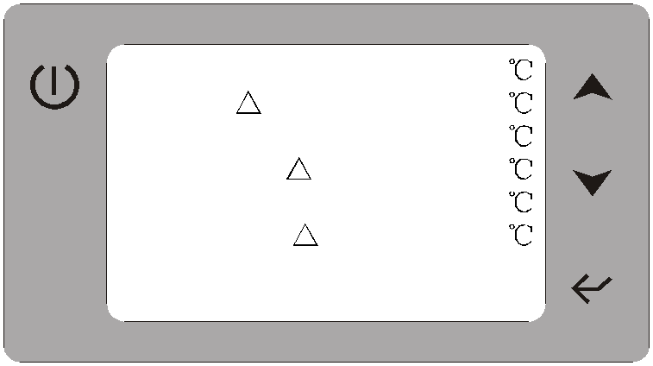

|  |  |  |  |  |  |  |  |
| --- | --- | --- | --- | --- | --- | --- | --- |
| Mode | Heating |  | 1.1 Hot water temp. | 55 |  | 3.1 Aux.elec. T | 5 |
|  |  |  | 1.2 H.W T | 5 |  | 3.2 Aux.start delay | 30M |
| A.C.heat temp. | 40 |  | 1.3 Heating temp. | 40 |  | 3.3 Ambient temp.set | 15 |
|  | | |  |  | | | |
|  |  |  | | | | | |

1.6 Cooling T 5

Prg

Ese

The parameter setting of Heatling mode

1.Parameter 1.3 under air condition side heating mode,the setting of water inlet temperature .

2.Parameter 1.4 under air condition side heating mode,the compressor restart difference temperature.

3.Note: when Aux.heatinig is ON, and the electric heater also meet the requirement of parameter3.1~3.3, so then the electric heater can work.

Parameter 3.1 :Under hot water electric heating mode, the electric heating restart difference temperature.

Parameter 3.2: Auxiliary electric heater start delay time (the time to delay after unit power on, the electric heater allows to output).

Parameter 3.3:The auxiliary electric heater start ambient temperature(When the ambient

temperature is below the set temperature, the electric heating allows the output .

Hot water mode



4.7 Cooling mode

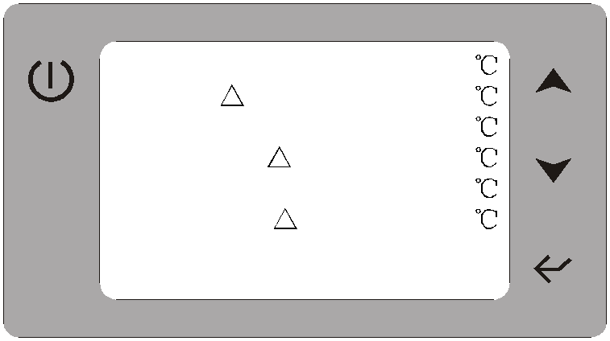

|  |  |  |  |  |  |  |  |  |  |
| --- | --- | --- | --- | --- | --- | --- | --- | --- | --- |
| Prg | Mode | Hot water |  |  | 1.1 Hot water temp. | 55 |  |  | 4.1 Power memory On |
|  |  |  |  | 1.2 H.W T | 5 |  |  | 4.2 Economic mode Off |
| Hot water temp.  Aux. Heating | 55  on |  | Prg | 1.3 Heating temp.  1.4 Heating T | 40  5 |  | Prg | 4.3 H.W.pump Normal  4.4 EVI valve 5 |
|  |  |  |  |  | 1.5 Cooling temp. | 12 |  |  | 4.5 Comp.PT temp. 105 |
|  |  |  |  |  | 1.6 Cooling T | 5 |  |  | 4.6 E.H.H.W.pump Special |
| Ese |  |  |  | Ese |  |  |  | Ese | 4.8 Elec.mode Heat&H.W |

Off

The parameter setting of hot water mode

1.Parameter 1.1 the setting temperature of hot water.

2.Parameter1.2 hot water mode,the compressor restart difference temperature.

3.Parameter4.3 hot water cycle pump working mode option.

Special:hot water tank temp. reaches the set temperature, the hot water cycle pump keep working.

Normal:hot water tank temp. reaches the set temperature, the hot water cycle pump stop working.

4.Note: when Aux.heatinig is ON, and the electric heater also meet the requirement of parameter3.1~3.3, so then the electric heater can work.

Parameter 3.1 :Under hot water electric heating mode, the electric heating restart difference temperature.

Parameter 3.2: Auxiliary electric heater start delay time (the time to delay after unit power on, the electric heater allows to output).

Parameter 3.3:The auxiliary electric heater start ambient temperature(When the ambient

temperature is below the set temperature, the electric heating allows the output .

Heating+Hot water mode



Ese

Mode Heating

Hot water

A.C.heat temp. 40

|  |  |  |  |
| --- | --- | --- | --- |
| Prg | Hot water temp. | 55 | Prg |

Priority H.W

|  |  |  |  |  |  |  |  |
| --- | --- | --- | --- | --- | --- | --- | --- |
|  | |  |  |  |  |  |  |
|  |  |  |  |  |  |  | 4.7 Cooling mode Off |
|  | Ese |  |  |  |  | Ese | 4.8 Elec.mode Heat&H.W |

1.1 Hot water temp. 55

1.2 H.W T 5

1.3 Heating temp. 40

1.4 Heating T 5

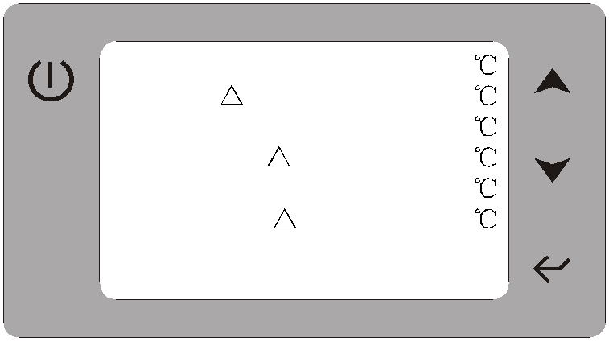

1.5 Cooling temp. 12

Prg

4.1 Power memory

4.2 Economic mode

4.3 H.W.pump

4.4 EVI valve

4.5 Comp.PT temp.

On Off Normal

5

105

Cooling+Hot water mode



Hot water temp. 55

Prg

1.4 Heating T 5

Prg

4.4 EVI valve 5

4.7 Cooling mode

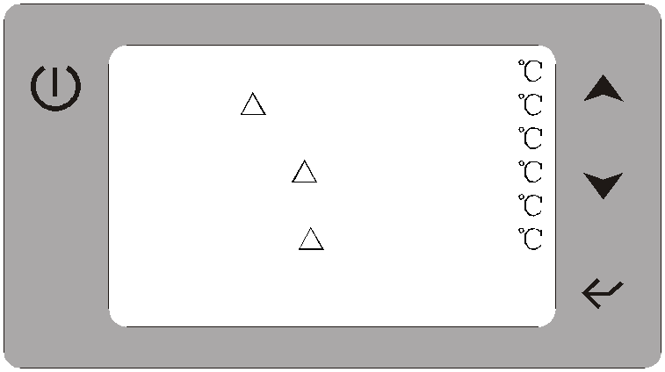

|  |  |  |  |  |  |  |  |  |  |  |
| --- | --- | --- | --- | --- | --- | --- | --- | --- | --- | --- |
| Prg | Mode | Cooling |  | | 1.1 Hot water temp. | 55 |  | | 4.1 Power memory | On |
|  | Hot water |  | | 1.2 H.W T | 5 |  | | 4.2 Economic mode | Off |
| A.C.cool temp. | 12 |  | | 1.3 Heating temp. | 40 |  | | 4.3 H.W.pump | Normal |
|  | | | |  |  | | | | |
|  |  |  |  |  |  |  |  |  | |
| Priority | H.W |  |  | 1.5 Cooling temp. | 12 |  |  | 4.5 Comp.PT temp. 105 | |
|  |  |  |  |  | 1.6 Cooling T | 5 |  |  | 4.6 E.H.H.W.pump Special | |
| Ese |  |  |  | Ese |  |  |  | Ese | 4.8 Elec.mode Heat&H.W | |

Off

Note:Parameter4.7 whether open the cooling function to the user interface

On:open Off: don t open

Manual operation electric heater mode



Legend:

|  |  |  |  |  |  |  |  |
| --- | --- | --- | --- | --- | --- | --- | --- |
| MODE Off MODE Off | | | | | | | This icon means the manual |
|  | A.C. water Inlet | 12 |  | A.C. water Inlet | 12 |  | electric heating model is in |
| Prg | Hot water tank | 25 | Prg | Hot water tank | 25 |  | operation |
|  | Solar Collector | 25 |  | Solar Collector | 25 |  |  |
| Ambient temp. 30 Ambient temp. 30  Ese 2011-04-08 11:25 Ese 2011-04-08 11:25 | | | | | | | |

|  |  |  |
| --- | --- | --- |
|  |  |  |
|  |  |  |

Press button for 5 s

(turn on the mode)

The parameter setting of Manual operation electric heater mode

1.Parameter4.6 when the unit running manual electric heating mode the hot water cycle pump working way.

Special:the hot water cycle pump required output. Normal:the hot water cycle pump not required output.

2.Parameter4.8 the application of manual electric heater

Heat: air condition heating auxiliary electric heater

Heat&H.W: air condition heating and hot water auxiliary electric heater

Manual operation water supply function



Legend:

|  |  |  |  |  |  |  |  |
| --- | --- | --- | --- | --- | --- | --- | --- |
| MODE Off MODE Off | | | | | | | This icon means the manual |
|  | A.C. water Inlet | 12 |  | A.C. water Inlet | 12 |  | water supply output is in |
| Prg | Hot water tank | 25 | Prg | Hot water tank | 25 |  | operation |
|  | Solar Collector | 25 |  | Solar Collector | 25 |  |  |
| Ambient temp. 30 Ambient temp. 30  Ese 2011-04-08 11:25 Ese 2011-04-08 11:25 | | | | | | | |

|  |  |  |
| --- | --- | --- |
|  |  |  |
|  |  |  |

Press button for 10 s

(turn on/turn off the water supply )

Automatic water supply function



Parameter 7.1 whether turn on the automatic constant temp. water supply function,

7.1 Water supply On

7.2 Supply temp. 40

7.3 Supply T 5

ON means turn on (work with parameter 7.4,) OFF means turn off

Parameter 7.2 the water supply return temp. setting

Prg

Ese

7.4 Timer 16:00-23:00

Parameter 7.3 the temp. difference between the water supply return temp. and the setting temp.

Parameter 7.4 the automatic constant temp. water supply time setting (work with

parameter 7.1)

**3.System State parameter checking:**

On the main interface,press

Prg

enter into parameter setting interface,choose

"Main menu " press button,choose "Unit status",press into the mode setting,press

to view the paramter, press

Ese

return to the previous menu.

Prg

Ese

Main menu Maintenance Clock

Water supply setting

Prg

Ese

Mode select

Unit status

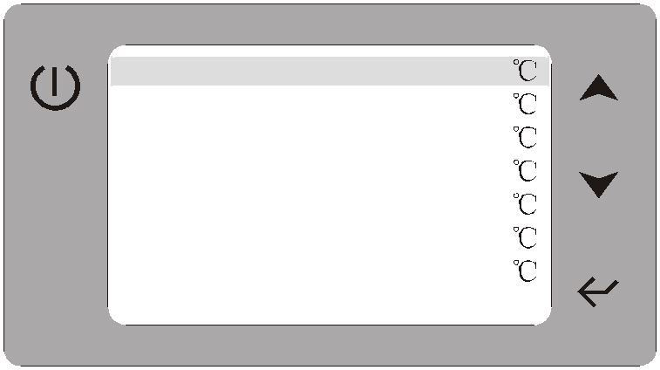

Prg

Ese

Inlet water 12

Outlet water 8

Hot water temp. 25

Ambient temp. 25

Coil temp. 25

Discharge temp. 95

Solar temp. 30

Compressor On

Press button

Unit State parameters

Press button

|  |  |  |
| --- | --- | --- |
| **Display** | **Status** | **Means** |
| Inlet water | 12 | Water inlet temp. |
| Outlet water | 8 | Water outlet temp. |
| Hot water temp. | 25 | Hot water tank temp. |
| Ambient temp. | 28 | Ambient temp. |
| Coil 1temp. | 25 | System 1 coil temp. |
| Coil 2temp. | 25 | System 2 coil temp. |

|  |  |  |
| --- | --- | --- |
| **Display** | **Status** | **Means** |
| Discharge 1 temp. | 85 | System 1 discharge temp. |
| Discharge 2 temp. | 85 | System 2 discharge temp. |
| Solar temp. | 30 | Solar collector temp. |
| Return temp. | 40 | Water supply return temp. |
| Compressor 1 | On | System 1 compressor On/off |
| Compressor 2 | On | System 2 compressor On/off |
| 4way-valve | On | System 4-way valve on/off |
| H.W.pump | On | Hot water pump On/off |
| A.C. Pump | On | Air condition water pump on/off |
| Solar pump | On | Solar water cycle pump on/off |
| Fan motor | On | Fan motor on/off |
| 3way-valve | On | 3-way valve on/off |
| Aux.electric | On | Auxiliary electric heater on/off |
| Unload valve | On | System unload valve on/off |
| EVI valve | On | System EVI valve on/off |
| Supply output | On | Supply output on/off |
| H.W.flow sw | Close | Hot water side water flow switch |
| A.C.flow sw | Close | Air condition side water flow switch |
| Sys.1 HP sw | Close | System 1 high pressure switch |
| Sys.1LP sw | Close | System 1 low pressure switch |
| Sys.2 HP sw | Close | System 2 high pressure switch |
| Sys.2 LP sw | Close | System 2 low pressure switch |
| On/off sw | Close | Unit turn on/off switch |
| Mode sw | Close | Unit mode switch |
| Electric sw | Open | Turn on/off auxiliary electric mode |
| A.C.on/off sw | Close | Air condition turn on/off switch |
| Phase PT sw | Close | Power phase protection |
| Aux.elec.PT sw | Close | Auxiliary electric protection switch |

**4. System parameter setting:**

On the main interface,press the button

Prg

enter into page2(picture1),press

Prg

for 5 second until hear the beep ,one more parameter parameter)appear, press

to view the parameter, choose Parameter and press to enter the paremters setting interface,press to view the parameter,press to enter the paremters setting interface press to view the parameter, press

to enter the system paremters setting interface,corresponding parameter flashing,

press to modify,press

Ese

to return previous menu.

Prg

Ese

Main menu Maintenance Clock

Water supply setting

Prg

Ese

Main menu Parameter Maintenance Clock

Water supply setting

Press

Prg

button for 5 second until hear the beep

4.1 Detailed description of the function parameters

Parameters 1.0 select Temp.setting

Parameter 1.1:Under hot water mode the setting of water tank temperature.

Prg

Ese

1.1 Hot water temp. 55

1.2 H.W. T 5

1.3 Heating temp. 40

1.4 Heating T 5

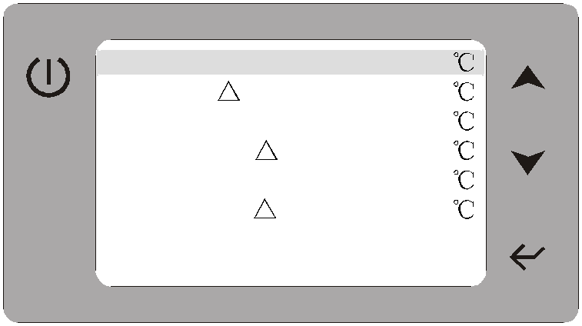

1.5 Cooling temp. 12

1.6 Cooling T 5

Parameter 1.2:Under hot water mode,the compressor restart difference temperature. Parameter 1.3:Under heating mode, the setting of water inlet temperature .

Parameter 1.4:Under heating mode, the compressor restart difference temperature. Parameter 1.5:Under Cooling mode, the setting of water inlet temperature .

Parameter 1.6:Under Cooing mode, the compressor restart difference temperature.

Parameters 2.0 select Defrost

Parameter 2.1: Cycle defrost cycle time setting.

Prg

Ese

2.1 Def. cycle

2.2 Def. inlet temp.

2.3 Def. outlet temp.

2.4 Def. max. time

40M

-7

13

8M

Parameter 2.2: Into the defrost state conditions. When the coil temperature is below this parameter setting, the conditions are met.

parameter 2.3: Exit defrost state condition 1, when the coil temperature is higher than the set value of this parameter, the condition is met.

parameter 2.4: out defrost state condition 2, when the defrost time is running

larger than this parameter setting the time, conditions are met.

Parameters 3.0 select Aux-heating

Parameter 3.1:The auxiliary electric heater restart difference temperature.

Prg

Ese

3.1Aux.elec. T

3.2Aux.start delay

3.3 Ambient temp.set

5

30M

15

Parameter 3.2: Auxiliary electric heater start delay time (the time to delay after unit power on, the electric heater allows to output).

Parameter 3.3:The auxiliary electric heater start ambient temperature(When the ambient temperature is below the set temperature, the electric heating

allows the output .

Parameters 4.0 select Systems

Parameter 4.1: Power-down memory options parameters.

Prg

4.1 Power memory

4.2 Economic mode

4.3 H.W.pump

4.4 EVI valve

4.5 Comp.PT temp.

4.6 E.H.H.W.pump

4.7 Cooling mode

On Off Normal

5

105

Special

Off

On: with memory Off: without memory Parameter 4.2:Whether turn on the economic mode. Parameter 4.3: Hot water cycle pump working way.

Normal: when the hot water tank temperature reach the setting temperature the

Ese

4.8 Elec.mode

Heat&H.W

hot water pump stop working.

Special: when the hot water tank temperature reach the setting temperature the hot water pump keep working.

Parameter 4.4:The setting of ambient temperature to turn on the EVI valve.

Parameter 4.5: Compressor discharge temperature too high protection exhaust temperature setting. Parameter4.6 When the unit running manual electric heating mode the hot water cycle pump working way.

Special:the hot water cycle pump required output. Normal:the hot water cycle pump not required output.

Parameter4.7 Whether open the cooling function to the user interface

On:open Off: don t open

Parameter4.8 The application of manual electric heater

Heat: air condition heating auxiliary electric heater

Heat+H.W: air condition heating and hot water auxiliary electric heater

Parameter4.9 System number select

1:single system 2:double system

Parameter4.10 Unit stop temp.(the temp.setting of ambient temp.too low protection)

Parameters 5.0 select Solar setting

Parameter 5.1: Solar pump starts difference temperature set. The difference

Prg

Ese

5.1 Solar start T 6

5.2 Solar stop T

temperature of solar collectors measured values and hot water tank measured temperature.

Parameters 6.0 select Water pump testing

Prg

Ese

H.W. pump A.C. pump Solar pump

3way-valve

Supply output

on/off on/off on/off on/off on/off

Parameter 6.0: This parameter is used by engineers debugging parameters, you can manually open the air-conditioning pumps, water pumps, solar water pump

3way-valve and supply output parameter.

**5. The maintenance time inquires**

In the interface ,press

Prg

to enter parameter setting interface,choose "Maintenance''

and press to enter Maintenance time inquires, press to turn a choice,

and press

Ese

key returns the last menu.

Prg

Ese

09:50

|  |  |  |  |  |
| --- | --- | --- | --- | --- |
| Main menu |  | 1: E01 | 2010-01-14 | 09:00 |
| Parameter |  | 2: P01 | 2010-01-14 | 09:10 |
| Maintenance |  | 3: E08 | 2010-01-14 | 09:30 |
| Clock Prg  Water supply setting | | 4: E05 | 2010-01-14 | 09:40 |
| 5: P06 | 2010-01-14 |  |
| 6: P08 | 2010-01-14 |  |
| Ese | | 7: P12 | 2010-01-14 | 10:10 |
| 2010-01-14 | 10:20 |  |

10:00

|  |  |  |
| --- | --- | --- |
| Picture1 |  | Picture2 |
| NOTE:In the picture 2 interface,press the | prg | button for 5 seconds ,the fault record will |

remove.

**6. Date/ time/ timing on and off settings**

In the main interface, press

Prg

key to enter the parameter setting interface, select

Clock, press key to enter the time setting / timing on or off interface, press the key to turn options:

Note: Press

Prg

button for 5 seconds, when you hear the beep sound, you can see

the page to add Timer on and Timer off select column.

Prg

|  |  |  |  |  |
| --- | --- | --- | --- | --- |
| Date | 2010-04-15 |  | Date | 2010-04-15 |
| Clock | 18:30 |  | Clock | 18:30 |
|  |  |  | Timer on | X |
|  |  | Prg | Timer off | X |

Ese

Ese

Press

Prg

button for 5 second until hear the beep

6.1 . When you select "Date", press key, the date of the year setting flash, press the key to modify Year, then press key again, the month setting flash,press the

key to modify the month, click the key again, Day flash, press the

key to modify the day, then press key to confirm and exit, press the return the layer menu.

Ese

button to

6.2. When you select "Clock", press the key, the time hourly position flash, press the

key to modify hour value, then press key, minutes flash, press the

key to modify the minute value, press the key again confirm and exit, press the to return the layer menu.

Ese

6.3. When you select "Timer on", press the key, regular on or off setting flash, press key to modify the boot time whether on / off, appear " " symbol when choose on,

and show regular boot time settings, click the key, regular on or off hour value setting flash, press the key to modify the value, then press key, regular on or off minute

value setting flash, press key to modify the value, press key to confirm and exit,

press the

Ese

"Ese" to return the layer menu.

**7. Lock button/Defrost status/ Fahrenheit and Celsius change:**

**A: Display Lock** Under the main interface :Press

**Prg**

for 5s, the interface will show the

icon as shown in figure .then, all buttons on the display are locked, but it can be

unlocked after pressing

**Prg**

for 5s again.

**B:Defrost status :**When the unit are running heating or hot water mode, if the main interface is showing the  icon as shown in figure ,that means the unit are running the defrost status

**C: Fahrenheit and Celsius change** Under the Celsius status, press

Ese

for 10 s can changed Fahrenheit ,it will cha nge to Celsius again when press for 10s.

Ese

Defrost status icon

Lock icon

Prg

Ese

MODE

A.C. water Inlet Hot water tank Solar Collector Ambient temp.

2011-04-08 11:25

Off

12

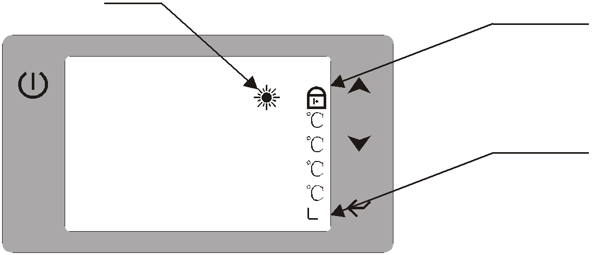

25

25

30

Timer icon

**8. Fault code display**

When a fault, unit controller display automatically corresponding fault code and the fault reasons. When fault resolution, fault display automatically eliminate or after re-power to eliminate.

**9. Parameter Table**

**setting range**

2:double system

|  |  |  |  |  |  |
| --- | --- | --- | --- | --- | --- |
| **Display code1** | **Display code2** | **Setting data explanation or working state** | **Parameter** | **Default** | **Remarks** |
| Parameter |  |  |  |  |  |
| 1.0 Temp.setting | 1.1 Hot water temp. | The setting temp.of hot water mode | 10 60 | 55 | Adjustable |
| 1.2 H.W. T | Hot water mode,the compressor  restart difference temperature | 1 15 | 5 | Adjustable |
| 1.3 Heating temp. | The setting temp.of heating mode | 15 60 | 40 | Adjustable |
| 1.4 Heating T | Heating mode,the compressor  restart difference temperature | 1 15 | 5 | Adjustable |
| 1.5 Cooling temp. | The setting temp.of cooling mode | 8 28 | 12 | Adjustable |
| 1.6 Cooling T | Cooling mode,the compressor restart difference temperature | 1 15 | 5 | Adjustable |
| 2.0 Defrost | 2.1 Def. Cycle | defrosting cycle setting | 30min 90min | 40min | Adjustable |
| 2.2 Def. inlet temp. | Start defrosting coil temperature setting | -30 -0 | -7 | Adjustable |
| 2.3 Def. outlet temp. | Exit defrost temperature setting | 1 30 | 13 | Adjustable |
| 2.4 Def. Max. Time | Defrost time setting | 1min 12min | 8min | Adjustable |
| 3.0 Aux-heating | 3.1 Aux.elec. T | Auxiliary electric heating mode, the electric restart difference temp. | 1 15 | 5 | Adjustable |
| 3.2 Aux.start delay | Auxiliary electric heater start delay | 3min 90min | 30min | Adjustable |
| 3.3 Ambient temp.s et | Auxiliary electric heater start to work when ambient temperature lower than the setting value | -20 45 | 15 | Adjustable |
| 4.0 Systems | 4.1 Power memory | Power-down memory options parameters. | ON/OFF | ON | ON: with  OFF: without |
| 4.2 Economic mode | Whether turn on the economic mode parameters. | ON/OFF | OFF | ON: automatic  OFF: manual |
| 4.3 H.W.pump | Hot water pump working way | Special/Normal | Special | Special: turn on  Normal: turn off |
| 4.4 EVI valve | The setting of turn on EVI valve  (effective for the EVI unit) | -20 ~ 30 | 5 | Adjustment |
| 4.5 Comp.PT temp. | Compressor discharge temp.too high protection setting. | 30 ~ 125 | 105 | Adjustment |
| 4.6 E.H.H.W.pump | Electric heating mode, hot water pump working way. | Special/Normal | Special | Adjustment |
| 4.7 Cooling mode | Wether open the cooling function to the  interface of user | ON/OFF | Off | Adjustment |
| 4.8 Elec.mode | The use of manual electric heating mode | Heat/Heat&H.W | Heat&H.W | Adjustment |
| 4.9 System number | System number select | 1:signle system | 1 | Adjustment |
| 4.10 Unit stop temp. | The temp.setting of ambient temp. Too low protection | -30 ~ 10 | -15 | Adjustment |
| 5.0 Solar setting | 5.1 Solar start T | Solar start temperature difference  setting | 1 ~ 20 | 6 | Adjustment |
| 6.0 Water pump testing | H.W. Pump | Hot water pump testing | ON/OFF | OFF | Adjustment |
| A.C. pump | Air conditioner pump testing | ON/OFF | OFF | Adjustment |
| Solar pump | Solar pump testing | ON/OFF | OFF | Adjustment |
| 3way-valve | 3way-valve testing | ON/OFF | OFF | Adjustment |
| Supply output | Supply output testing | ON/OFF | OFF | Adjustment |
| 7.0 Water supply testing | Water supply | Turn on /turn off the automatic water supply function | On: turn on  Off: turn off | OFF | Adjustment |
| Supply temp. | The setting temperature of water supply return temp. | 30 ~ 55 | 40 | Adjustment |
| Supply T | The water supply pump restart work difference temperature | 2 ~ 30 | 5 | Adjustment |
| Timer | The automatic water supply function time setting | 00:00~ 24:00 |  | Adjustment |

IV. Installation sketch

**1.Hot water mode installation drawing**

Water supply

Hot water

Auxiliary electric

Auxiliary electric

Floor heating

**Unit electric box**

return temp.

tank temp.

heater power input

heater power

Hot water pump (air condition) pump Water supply

Outdoor fan

Three way valve

CN9

output

power output

power output

pump power

output

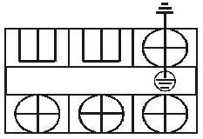

power output

power output

R S T N

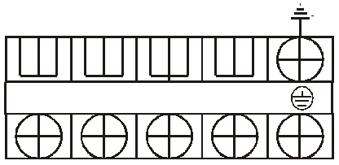

L N 1 2 L N 1 2



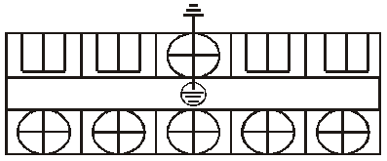

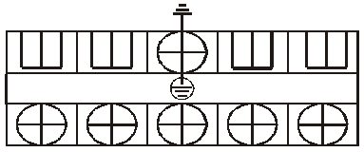

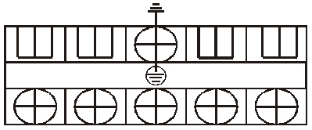

L N 1 2 L N

Power input

(380VAC/3PH/50Hz)

A B

7 3 5

**1** 8

Wire controller

A Cold water inlet

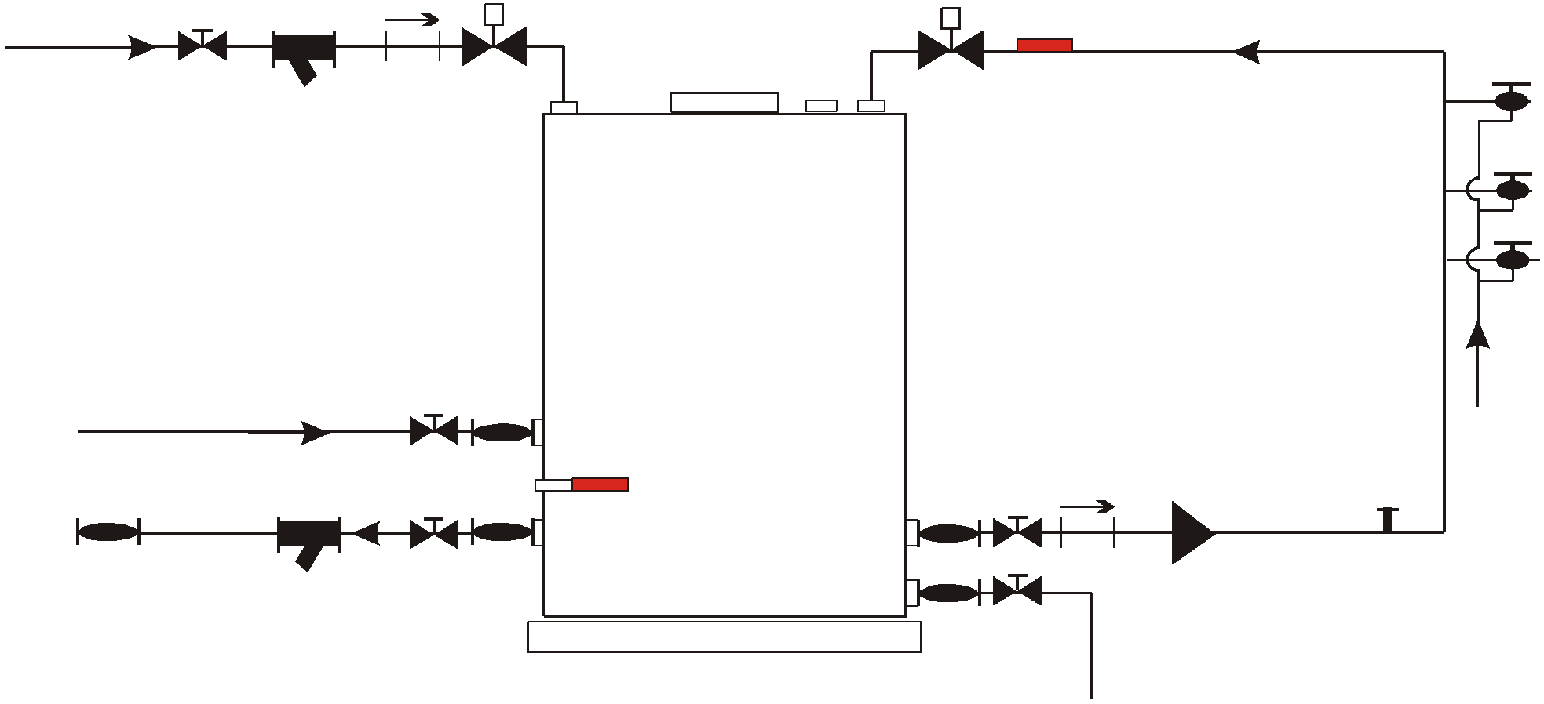

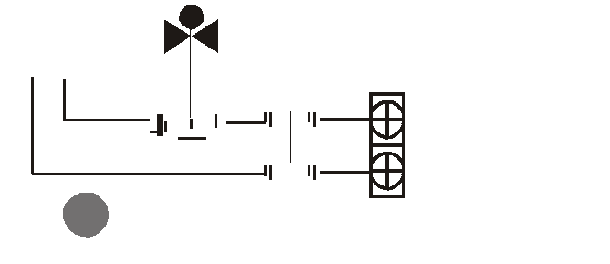

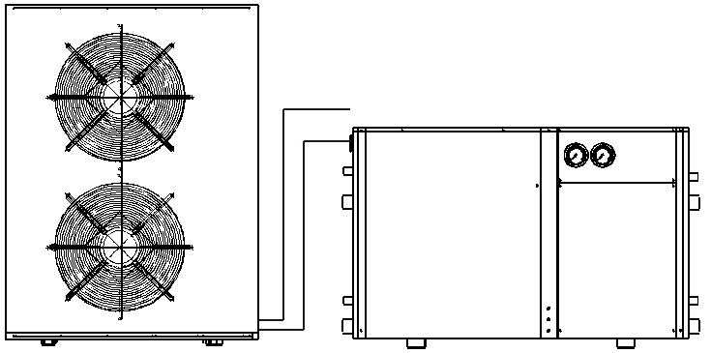

2 3

6

Cold water inlet

B

5

8 1 7

4 **Power**

**(220V ~)**

**L N**

**1**

Legend:

Globe valves

Electric driven two-way valve

Shower head

1 Unit

8 Outdoor fan unit

Check valve

Water pressure switch

2 Water filling valve

3 Water supply return valve

A Water supply return temp.

B Hot water tank temp.

Air-break switch

Water temp. sensor

4 Open wide type hot water tank

5 Water supply cycle pump

Expansion Tank

6 Bath room

7 Hot water cycle pump

**The parameter setting for domestic hot water model:**

|  |  |  |  |  |
| --- | --- | --- | --- | --- |
| Parameter |  |  |  |  |
| 1.1 Hot water temp. | The setting temp.of hot water mode | 10 60 | 55 | Adjustable |
| 1.2 H.W. T | Hot water mode,the compressor  restart difference temperature | 1 15 | 5 | Adjustable |
| 4.3 H.W.pump | Hot water pump working way | Special/Normal | Normal | Special: turn on  Normal: turn off |
| 7.1 Water supply | Turn on /turn off the automatic water supply function | On: turn on  Off: turn off | On | Adjustable |
| 7.2 Supply temp. | The setting temperature of water supply return temp. | 30 ~ 55 | 40 | Adjustable |
| 7.3 Supply T | The water supply pump restart work difference temperature | 2 ~ 30 | 5 | Adjustable |
| 7.4 Timer | The automatic water supply function time setting | 00:00~ 24:00 | 16:00~ 23:00 | Adjustable |

NOTE **1** :When the water supply system with water pressure switch , use the water pressure switch control water supply pump independently , as shown in figure, if do not installed water pressure switch ,then connect the water supply pump to water supply output port

**2.Heating mode installation drawing**

CN9

Auxiliary electric

Auxiliary electric

**Unit electric box**

heater power input

heater power

Hot water pump

Floor heating

Water supply

Outdoor fan

Three way valve

output

power output (air condition) pump

power output

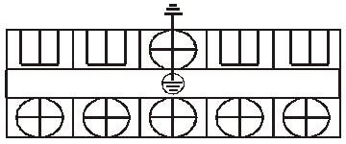

pump power

output



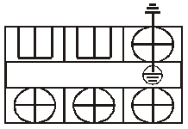

power output

power output

R S T N

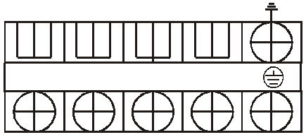

L N 1 2 L N 1 2



L N 1 2 L N

Wire controller



Power input

(380VAC/3PH/50Hz)

22 23

SW6(Air condition turn on/turn off switch)

close circuit :turn on open circuit: turn off

220V/50HZ

LN

23 1 22

L

2 220V/50HZ

5 3 N

6 5 6

4

























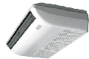



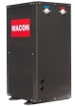



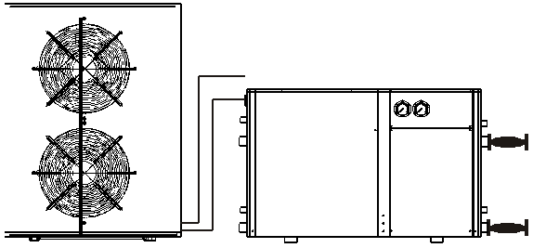



7 8

thermostat controller

three-way valve

Relay

L

220V/50HZ

N

9 10

11 12



9 10

thermostat controller three-way valve

Relay

L

220V/50HZ

N

13 14

15 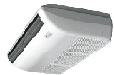 16

1 3 1 4

thermostat controller three-way valve

Relay

17

thermostat controller

L

220V/50HZ

N

19

20

21 18

17

three-way valve

Relay

pump power switch

21

Flexible connectors

Globe valves

Electric driven two-way valve

Electric three-way valve

Check valve

 Thermostat

 Expansion Tank

Hot water cycle pump

|  |  |  |  |  |
| --- | --- | --- | --- | --- |
| Unit | 12 | Room 4 Radiators | 21 Swimming pool side water cycle pump | |
| Buffer tank | 13 | Room 5 electric three-way valve | 22 | Hot water cycle pump |
| Water distribution device |  |  | 23 | Outdoor fan unit |

1

2

3

4 Water collection device

5 Room 1electric three way valve

6 Room 2 electric three way valve

7 Room 1 floor heating

8 Room 2 floor heating

9 Room 3 electric three way valve

10 Room 4 electric three way valve

11 Room 3 Radiators

14 Room 6 electric three-way valve

15 Room 5 fan coil

16 Room 6 fan coil

17 Swimming pool three-way valve

18 Water to water excharge

19 Swimming pool

20 Sand cylinder filter

**3.Hot water&Heating mode Hot water &cooling mode installation drawing**

CN9

Water supply

Hot water

Auxiliary electric

Auxiliary electric

**Unit electric box**

return temp.

tank temp.

heater power input

heater power

output

Hot water pump

power output

Floor heating

(air condition) pump power output

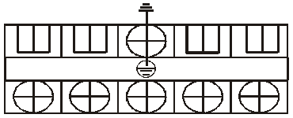

Water supply

pump power output

Outdoor fan

power output

Three way valve

power output

R S T N

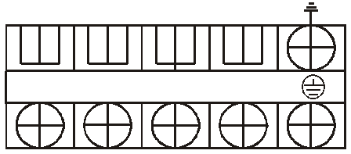

L N 1 2 L N 1 2

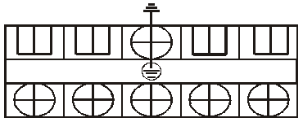

L N 1 2 L N

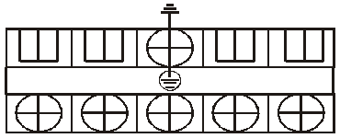

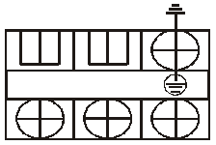

Wire controller A B



Power input

(380VAC/3PH/50Hz)

27 25

28 1

1

Note 1 1 24

28 1

B

22

27 23

24 A

26

25

2

power on : port 1 and 2 are connected power up : port 1 and 24 are connected

SW6(Air condition turn on/turn off switch)

close circuit :turn on open circuit: turn off

2

220V/50HZ

LN

L

220V/50HZ

5 3 N

6 5 6

4

























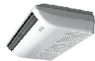







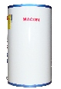









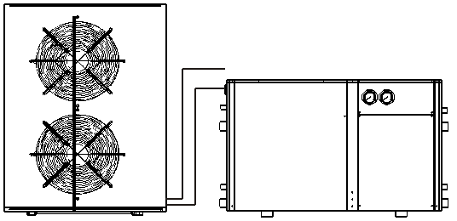



7 8

thermostat controller

three-way valve

Relay

L

220V/50HZ

N

9 10

11 12



9 10

thermostat controller three-way valve

Relay

L

220V/50HZ

N

13 14

15 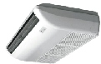 16

1 3 1 4

thermostat controller three-way valve

Relay

17

thermostat controller

L

220V/50HZ

N

19

20

21 18

17

three-way valve

Relay

pump power switch

21

Flexible connectors

Globe valves

Electric driven two-way valve

Electric three-way valve

5 Room 1electric three way valve

6 Room 2 electric three way valve

7 Room 1 floor heating

8 Room 2 floor heating

17 Swimming pool three-way valve

18 Water to water excharge

19 Swimming pool

20 Sand cylinder filter

Check valve

 Thermostat

 Expansion Tank

Hot water cycle pump

1 Unit

2 Buffer tank

9 Room 3 electric three way valve

10 Room 4 electric three way valve

11 Room 3 Radiators

12 Room 4 Radiators

13 Room 5 electric three-way valve

14 Room 6 electric three-way valve

21 Swimming pool side water cycle pump

22 Solar

23 Solar water pump

24 Hot water tank

25 Water supply pump

26 Bath room

3 Water distribution device

4 Water collection device

15 Room 5 fan coil

16 Room 6 fan coil

27 Hot water cycle pump

28 Outdoor fan unit

V. Maintenance and repair

**1.Malfunction Indicating Table. Determine and solve the malfuction by malfuction code as below:**

**1.1.operate display fault code mode**

|  |  |  |  |
| --- | --- | --- | --- |
| Wire  Controller | Malfunction | Reason | Resolution |
| E01 | Hot water tank temp. Sensor failure | The sensor is open or short circuit | Check or change the sensor |
| E02 | Water inlet temp. Sensor failure | The sensor is open or short circuit | Check or change the sensor |
| E03 | Water outlet temp. Sensor failure | The sensor is open or short circuit | Check or change the sensor |
| E04 | System1 Coil sensor failure | The sensor is open or short circuit | Check or change the sensor |
| E05 | System 2 Coil sensor failure | The sensor is open or short circuit | Check or change the sensor |
| E06 | Outdoor environment temp. Sensor failure | The sensor is open or short circuit | Check or change the sensor |
| E07 | Water supply return temp. Sensor failure | The sensor is open or short circuit | Check or change the sensor |
| E08 | System 1 discharge sensor failure | The sensor is open or short circuit | Check or change the sensor |
| E09 | System 2 discharge sensor failure | The sensor is open or short circuit | Check or change the sensor |
| E10 | Communication failure | Wire controller and The  PCB connection failure. | Check the wire connection |
| E11 | Solar collector temp. Sensor failure | The sensor is open or short circuit | Check or change the sensor |
| P01 | Phase failure protection | Power supply phase failure /lacking | Check whether power supply phase failure or lacking, if failure, please connect it in according to the proper way. |
| P02 | Electric heater auxiliary overheating  & dry heating protection | The overheat protection is opened | Check whether the water flow and electric heating  is working normal then push the reset button on the overheat protection switch. |
| P03 | Hot water flow switch protection | No water/little water in water system. | Check the water flow volume, water pump is failure or not. |
| P04 | Air condition (Floor heating) side water flow switch protection | No water/little water in water system. | Check the water flow volume, water pump is failure or not. |
| P05 | System 1 high pressure protection | System 1 high pressure switch protection | Check whether the pressure switch and system return route failure. |
| P06 | System 1 low pressure protection | System 1 low pressure switch protection | Check whether the pressure switch and system return route failure. |
| P07 | System 2 high pressure protection | System 2 high pressure switch protection | Check whether the pressure switch and system return route failure. |
| P08 | System 2 low pressure protection | System 2 low pressure switch protection | Check whether the pressure switch and system return route failure. |
| P09 | 3 times of excessive temp. differentials of inlet water  and outlet water in 30minutes | Water flow volume not enough, water pressure difference is too low | Check the water flow volume,  or water system is blocked or not. |
| P10 | Antifreezing protection in winter | when the outdoor temp. below 0 under standby model | after the antifreezing procedure ,unit will return to the original state automatically |
| P11 | System 1 discharge temp. too high protection | 1.whether gas of system leak or not  2.the tank temp. Be set too high | 1 check the refrigerent amount in the system  2 check whether the tank temp. Setting value too high |
| P12 | System 2 discharge temp. too high protection | 1.whether gas of system leak or not  2.the tank temp. Be set too high | 1 check the refrigerent amount in the system  2 check whether the tank temp. Setting value too high |

**VI. Wiring diagram**

1 2 3 4

**1. Mk3092 PCB input and output port definition**

CN10

CN9

|  |  |  |  |  |  |  |  |  |  |  |  |  |  |  |  |  |  |  |  |  |  |  |  |  |  |  |  |  |  |  |  |  |  |  |  |  |  |  |  |
| --- | --- | --- | --- | --- | --- | --- | --- | --- | --- | --- | --- | --- | --- | --- | --- | --- | --- | --- | --- | --- | --- | --- | --- | --- | --- | --- | --- | --- | --- | --- | --- | --- | --- | --- | --- | --- | --- | --- | --- |
|  |  |  |  |  |  |  |  |  |  |  |  |  |  |  |  |  |  |  |  |  |  |  |  |  |  |  |  |  |  |  |  |  |  |  |  |  |  |  |  |
| 47 | 46 | 45 | 44 | 43 | 42 | 41 | 40 | 39 | 38 | 37 | 36 | 35 | 34 | 33 | 32 | 31 | 30 | 29 | 28 | 27 | 26 | 25 | 24 |  | 23 | 22 | 21 | 20 | 19 | 18 | 17 | 16 | 15 | 14 | 13 | 12 | 11 | 10 | 09 |

CN2

RP4

IC7

|  |  |  |  |
| --- | --- | --- | --- |
|  |  |  |  |
|  |  |  |

RP1

CC394B-V1.1

ON DIP

W101122

CN3

Mk3 0 9 2

E-VALVE2

CN1

|  |  |
| --- | --- |
| 08 |  |
| 07 |  |
| 06 |  |
| 05 |  |
| 04 |  |
| 03 |  |
| 02 |  |
| 01 |  |

E-VALVE1

IC12

IC6

TRAN-IN

FUSE

N3

N2

AC-L

AC-N

RY1

RY2 RY3 RY4 RY5 RY6 RY7 RY8

RY9 RY10 RY11 RY12 RY13

OUT1

OUT2 OUT3 OUT4 OUT5 OUT6 OUT7 OUT8 OUT9 OUT10 OUT11 OUT12 OUT13

|  |  |  |
| --- | --- | --- |
| NO . | Symbol | Meaning |
| 01 | CN1 | System 1 coil temp. |
| 02 | GND |
| 03 | System 1 discharge temp. |
| 04 | GND |
| 05 | System 2 coil temp. |
| 06 | GND |
| 07 | System 2 discharge temp. |
| 08 | GND |
| 09 | CN3 | GND |
| 10 | Water supply return water temp. |
| 11 | GND |
| 12 | Outlet water temp. |
| 13 | GND |
| 14 | Inlet water temp. |
| 15 | GND |
| 16 | Solar collector temp. |
| 17 | GND |
| 18 | Ambient temp. |
| 19 | GND |
| 20 | Hot water tank temp. |
| 21 | GND |
| 22 | Reservation |
| 23 | GND |
| 24 | CN2 | Turn on/turn off switch **3** |
| 25 | GND |
| 26 | Mode switch **2** |
| 27 | GND |
| 28 | Turn on/off aux.ele heater switch **1** |
| 29 | GND |
| 30 | System 1 high-pressure switch |
| 31 | GND |
| 32 | System 1 low-pressure switch |
| 33 | GND |

NOTE **1** : Closed circuit: turn on the manual electric heater mode.

|  |  |  |
| --- | --- | --- |
| NO . | Symbol | Meaning |
| 34 | CN2 | Hot water flow switch |
| 35 | GND |
| 36 | Air condition side water flow switch |
| 37 | GND |
| 38 | System 2 high-pressure switch |
| 39 | GND |
| 40 | System 2 low-pressure switch |
| 41 | GND |
| 42 | Hot water electric heating protection switch |
| 43 | GND |
| 44 | Turn on/off air heating/cooling switch **4** |
| 45 | GND |
| 46 | Phase sequence protection |
| 47 | GND |
|  | OUT1 | Compressor of system 1 |
|  | OUT2 | Compressor of system 2 |
|  | OUT3 | Fan motor |
|  | OUT4 | Unload valve |
|  | OUT5 | 4 way valve 1 |
|  | OUT6 | Hot water cycle pump |
|  | OUT7 | Floor heating(air condition) water cycle pump |
|  | OUT8 | Solar water cycle pump |
|  | OUT9 | Hot water auxiliary electric heating |
|  | OUT10 | Three-way valve |
|  | OUT11 | EVI valve(effective for the EVI unit) |
|  | OUT12 | Compressor crankshaft heater |
|  | OUT13 | Water supply output |
|  | AC-L | Power Input |
|  | AC-N | Power Input |
|  | N2 | Power Input(AC-N) |
|  | N3 | Power Input(AC-N) |
|  | TRAN-IN | Transformer input |
|  | CN9 | Wire controller |
|  | CN10 | Transformer output |

Open circuit : turn off the manual electric heater mode

NOTE **2** : Only effective when have not connected to the wire controller

Closed circuit: hot water+cooling mode. Open circuit : hot water + heatling mode

NOTE **3** : Useful when use dual energy for stopping compressor

Closed circuit: turn on

Open circuit : turn off

NOTE **4** :Air condition turn on/off switch

Short circuit: turn on the air condition mode(cooling or heating) Open circuit: turn off the air condition mode(cooling or heating)

**2. The electrical box of internal structure**

FUSE

2

N

16

**2.1 Mode:MACHRWS050W/S(E01)**

4

3

|  |  |  |
| --- | --- | --- |
|  |  |  |
|  |  |  |
|  |  |  |
|  |  |  |
|  |  |  |

Power

Run

L1

L2

CON1

IC6

Mk3077

JK1

N

12V-IN 12V-OUT

ON DIP

1 2 3 4

P5

P6

0057W

1

9

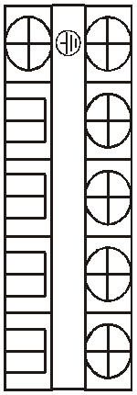

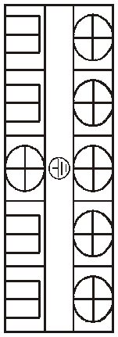

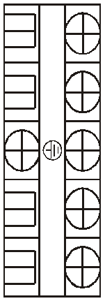

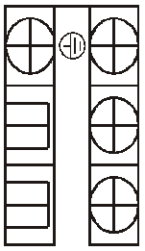

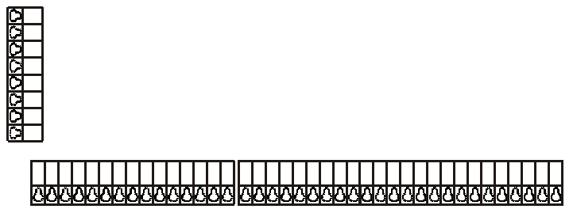

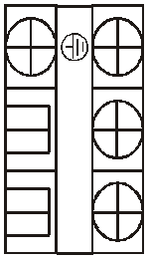

AC-N

OUT1 OUT2 OUT3 OUT4 OUT5 OUT6 OUT7 OUT8 OUT9 OUT10 OUT11 OUT12 OUT13

L1

R

S

T

0057W

11

15

2 5

F U S E

04

03

02

01

CN1

RP1

N2

RY1 RY2 RY3 RY4 RY5 RY6 RY7 RY8 RY9 RY10 RY11 RY12

RY13

E-VALVE1

E-VALVE2

A C - L

N

10

L

14

6

I C 7

IC12

TRAN-IN

N3

L N

L1 L2

2

1

R S T

13

7

RP4

1

ON DIP

06

05

CC394B-V1.1

W101122

1 2 3 4

CN3

CN10

CN9

CN2

08

07

SW1

09

10

11

12

13

14

15

16

17

18

19

20

21

22

23

24

25

26

27

28

29

30

31

32

33

34

35

36

37

38

39

40

41

42

43

44

45

46

47

8

N

NO .

Sign Meaning

NO .

IC6

Sign Meaning

1 TC

Transfer(220VAC/12VAC)

10 Three-way valve power output

2 MK3092 Controller

Mk3092

3 MK3077 Power phase protection board

11 Outdoor fan power output

12 Water supply pump power output

N

4 KM1

5 KA1

6 KA2

7 KA3

8 KA4

9

Compressor A.C.contactor 13

Hot water pump relay 14

Floor heating(air condition) pump relay 15

Solar water cycle pump relay 16

Water supply pump relay

Power 220VAC (public comment -N)

Solar water cycle pump power output Floor heating pump power output Hot water pump power output

Power input(380VAC/3PH/50Hz)

L

12

**2.2 Mode:MACHRW100W/S(E01)**

L2

IC6

Mk3077

ON DIP

1 2 3 4

1

|  |  |  |
| --- | --- | --- |
|  |  |  |
|  |  |  |
|  |  |  |
|  |  |  |
|  |  |  |

FUSE

Power

T

CON1

JK1

N

12V-IN 12V-OUT

P5

P6

0057W

L2 N2

L1 N1

L1

3 4 5 6

F U S E

IC12

TRAN-IN

N3

N2

RY1 RY2 RY3 RY4 RY5 RY6 RY7 RY8 RY9 RY10 RY11 RY12 RY13

AC-N

OUT1 OUT2 OUT3 OUT4 OUT5 OUT6 OUT7 OUT8 OUT9 OUT10 OUT11 OUT12 OUT13

A C - L

I C 7

|  |  |
| --- | --- |
|  |  |
|  |  |
|  |  |
|  |  |
|  |  |
|  |  |
|  |  |
|  |  |
|  |  |
|  |  |
|  |  |
|  |  |
|  |  |
|  |  |
|  |  |
|  |  |
|  |  |
|  |  |
|  |  |
|  |  |
|  |  |
|  |  |
|  |  |
|  |  |
|  |  |
|  |  |
|  |  |
|  |  |
|  |  |
|  |  |
|  |  |
|  |  |
|  |  |
|  |  |
|  |  |
|  |  |
|  |  |
|  |  |
|  |  |

CN3

CN9

CN10

CN2

SW1

CC394B-V1.1

W101122

RP4

RP1

Mk3092

IC6

09

10

11

12

13

14

15

16

17

18

19

20

21

22

23

24

25

26

27

28

29

30

31

32

33

34

35

36

37

38

39

40

41

42

43

44

45

46

47

ON DIP

1 2 3 4

2

L1

R

S

7 8

CN1

E-VALVE1

E-VALVE2

9

Run

0057W

10 11









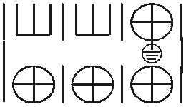

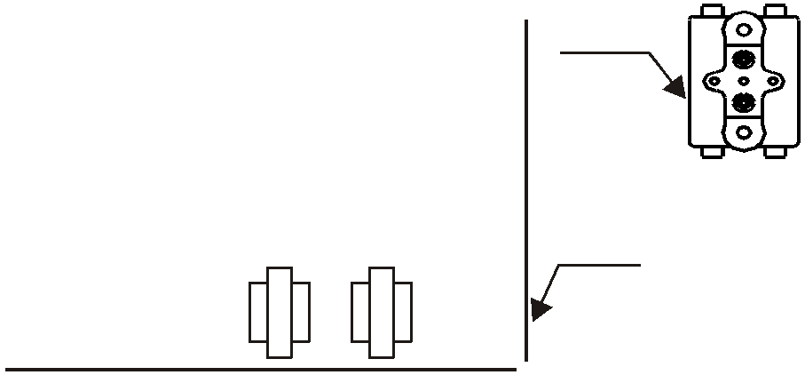

|  |  |  |  |  |  |  |  |
| --- | --- | --- | --- | --- | --- | --- | --- |
| 01 | 02 | 03 | 04 | 05 | 06 | 07 | 08 |
|  |  |  |  |  |  |  |  |

R S T N

L N 1 2

L N 1 2

L N 1 2 L N

12 13 14 15

16 17 18 19

NO .

Sign

Meaning

NO .

Sign Meaning

1 FP1

Auxiliary electric overheating protector

11 Tc

Transfer(220VAC/12VAC)

2 MK3077 Power phase protection board

12 Power input(380VAC/3PH/50Hz)

3 KA2

4 KA3

5 KA4

6 KA1

7

8 MK3092

9 KM1

10 KM2

Hot water pump relay 13

Floor heating(air condition) pump relay 14

Water supply pump relay 15

Outdoor fan power relay 16

Power 220VAC (public comment -N) 17

Controller 18

Compressor A.C.contactor 19

Auxiliary electric heater A.C.contactor

Auxiliary electric heater power input Auxiliary electric heater power output Hot water pump power outpout

Floor heating pump power output Water supply pump power output Outdoor fan power output

Three-way valve power output

**3. Mk3077 PCB Power protection board setting**

0057W

L1 L2

R

0057W

S

Power

Run

ON DIP

1 2 3 4

CON1

T JK1 IC6

FUSE

Mk3 0 7 7

N

P5

P6

12V-IN 12V-OUT

|  |  |  |
| --- | --- | --- |
| NO . | Symbol | Meaning |
| 1 | R | Power input |
| 2 | S | Power input |
| 3 | T | Power input |
| 4 | N | Power input |
| 5 | P5 | Protection signal output |
| 6 | P6 | Protection signal output |
| 7 | 12V-IN | power(12VAC)input |
| 8 | 12V-OUT | power(12VAC)output |

3.1.The setting of current protection value

For example:

Symbol :0

Symbol:1010

|  |  |  |  |
| --- | --- | --- | --- |
| Symbol | Current value | Symbol | Current value |
| 0011 | 8A | 1010 | 20A |
| 1101 | 9A | 0010 | 21A |
| 0101 | 10A | 1100 | 28A |
| 1001 | 11A | 0100 | 29A |
| 0001 | 12A | 1000 | 30A |
| 1110 | 18A | 0000 | 31A |

ON DIP

ON DIP

|  |  |  |  |
| --- | --- | --- | --- |
|  |  |  |  |
|  |  |
|  |  |

|  |  |  |  |
| --- | --- | --- | --- |
|  |  |  |  |
|  |  |  |  |

1 2 3 4

1 2 3 4

3.2 .Mk3077 PCB Power sequence, current protection board failure indication

Run led display Failure indication

ode Default

1flash 1 off L1 side overcurrent protection

M

MACHRW0

80ZB/PS(01) 12A MAC

The solution of fault

( should re-power on the heat pump after below operation)

Mode Default

1:Check whether the 3-phase poewr miss phase.

HRW150ZB/PS(01) 18A

2:check whether the AC contactor's retral contacting normal or not.

5flash 1 off

MACHRW1

6flash 1 off

L2 side overcurrent protection

Power phase sequence protection

00ZB/PS(01) 18A MAC

1:Check whether the 3-phase poewr miss phase.

2:check whether the AC contactor's retral contacting normal or not.

1:Check whether the 3-phase power sequence is right or wrong .

HRW200ZB/PS(01) 20A

2:Check whether the 3-phase power miss phase.

3.3.Every model's factory default value of current protection .

|  |  |  |  |
| --- | --- | --- | --- |
| Mode | Default | Mode | Default |
| MACHRW050W/S(E01D) | 18A | MACHRW100W/S(E01D) | 21A |
| MACHRW080W/S(E01D) | 18A |  |  |

3.4.Wiring diagram for wire controller and PCB

Wire controller

(Mk3093)

01

02

03

04

05

Brown

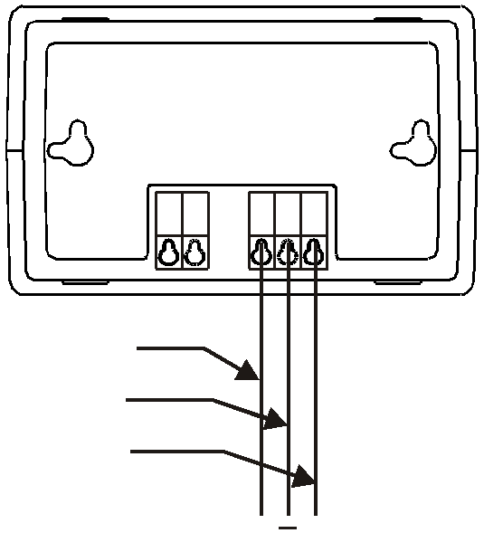

Blue

Yellow

Controller

(Mk3092) CN9

**4.Unit wiring diagram**

**4.1 Mode:MACHRWS050W/S(E01)**

OUT9

**Wiring diagram(MK3092-0501)**

OUT2

OUT6

OUT8

OUT10

T2 T1

T T

N

09

0 8

0 7

0 6

0 5

0 4

0 3

0 2

0 1

T3

10 CN1

OUT7

Fuse(220V/5A) L

OUT4

11

OUT12

OUT13

T4

12

T5 13

14

15

T6 16

T7 17

18

19

T8 20

21

Mk3092

CN3

OUT11

CN10

T R A N - I N

Red

OUT1

FU SE

R S

T

N

0057W

L1

SW1

SW2

SW3

HP1

LP1

SW4

SW5

SW6

FP1

P3

P4

22

23

24

25

26

27

28

29

30

31

32

33

34

35

36 CN2

37

38

39

40

41

42

43

44

45

46

47

KA3

OUT5

Va2

KA1 KA1 KA2 VA1

OUT3

KM1

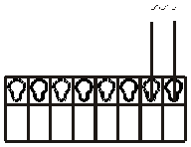

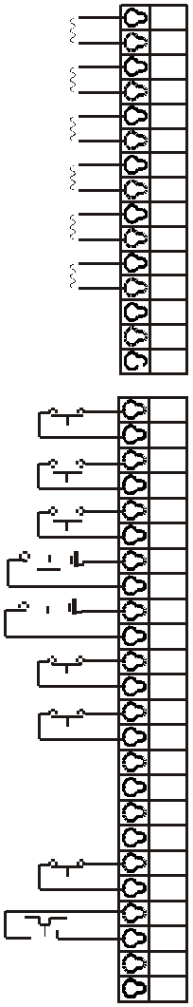

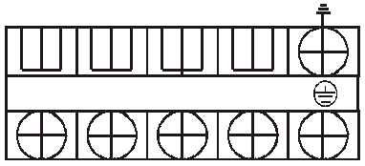

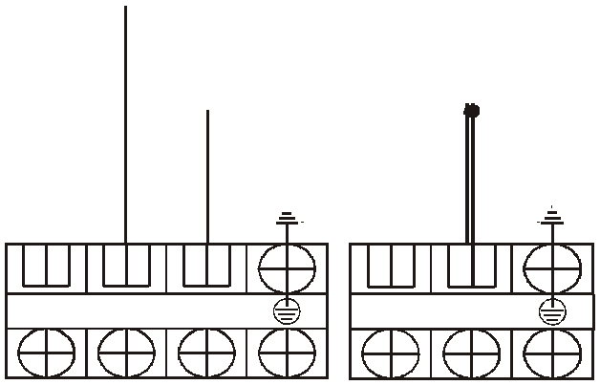

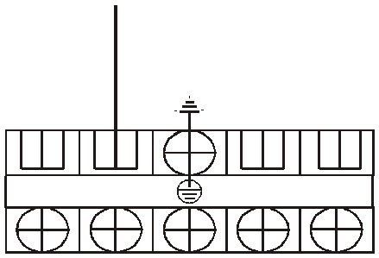

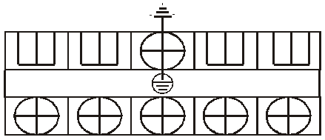

White

P3

P4 JK1

L2

12V-IN

12V-OUT

IC6

O N D I P

Mk3077

1 2 3 4

0057W

Power

Run

U V W

White Black Red

Compressor

CON1

KM1

L1 L2 N L N

L N 1 2

L N 1 2

R S T N

Three way valve

balck brown blue

Outdoor fan

Water supply

Solar water

Floor heating

Hot water pump

Power input

signal and power

pump power

pump power (air condition) pump

**Legend:**

output Va3

power output

output

output

power output

power output

(380VAC/3PH/50Hz)

: A.C.contactor/relay coil

: 4 way valve coil

HP1 LP1

:High pressure switch

:Low pressure switch

P4 : Power phase protection switch

P3

KM1: Compressor A.C.contactor

KA1 : Hot water pump relay

KA2 : Floor heating(air condition) pump relay

KA3 : Solar water pump relay KA4 : Water supply pump relay VA1: Four-way valve

VA2: EVI valve

VA3: Three-way valve

FP1

SW1

SW2

SW3

SW4

SW5

:Hot water auxiliary electric heater overload protection switch(short circuit)

: Unit turn on/turn off switch(short circuit)

: Model select switch(short circuit)

: Turn on/off auxiliary electric heater switch

(open circuit)

: Hot water side water flow switch

: Floor heating (air condition)side water flow switch

(short circuit)

T1 T

T2 T T3 T T4 T T5 T

T6 T

T7 T

T8 T

: System coil temp.

: System discharge temp.

: Water supply return water temp.

: Outlet water temp.

: Inlet water temp.

: Solar collector temp.

: Ambient t emp.

: Hot water tank temp.

SW6 : Floor heating(air heating/cooling) turn on/off switch(short circuit)

**4.2 Mode:MACHRW100W/S(E01)**

**Wiring diagram(MK3092-0101)**

OUT11

N Fuse(220V/5A)

OUT10

OUT7

OUT5

L

OUT9

OUT4

OUT3

OUT2

OUT1

CN10 TRAN-IN

Controller

OUT13

CN2

47

46

45

44

43

42

41

40

P3

P4

FP1

SW6

LP2

FU SE

T

N

P3

L2

P4

0057W

L1

R

S

0057W

Power

Run

ON DIP

1 2 3 4

White

P1P2

TC

Red

FP1

OUT8

OUT6

39

38

37

36

OUT12

35

34

HP2

SW5

SW4

JK1

12V-IN

CON1

IC6

P5

P6

Blue

White

Black

Red

KM1

|  |  |  |  |  |  |  |  |  |  |  |  |  |
| --- | --- | --- | --- | --- | --- | --- | --- | --- | --- | --- | --- | --- |
|  | 12V-OUT |  |  |  |  |  |  |  |  |  |  | 29 |
| P1  P2 | M k3 0 7 7 |  |  |  |  |  |  |  |  |  |  | 28  27  26 |
|  |  | U V W |  | KM1 |  | KA1 | VA1 KA2 KA3 | KM2 | VA2 CH1 KA4 |  |  | 25  24 |
|  |  |  |  |  |  |  |  |  |  |  |  | 23 |
|  |  | Compressor |  |  |  |  |  |  |  |  |  | 22 |
|  |  |  |  |  |  |  |  |  |  |  |  |  |
|  |  |  |  |  |  |  |  |  |  |  |  | 20 |
|  |  |  |  |  |  |  |  |  |  |  |  | 19 |
|  |  |  |  |  |  |  |  |  |  |  |  | 18 |
|  |  |  |  |  |  |  |  |  |  |  | CN3 | 17 |
|  |  |  |  |  |  |  |  |  |  |  |  |  |
|  |  |  |  |  |  |  |  |  |  |  |  | 15 |
|  |  |  |  |  |  |  |  |  |  |  |  |  |
|  |  |  |  |  |  |  |  |  |  |  |  | 13 |
|  | KM2 | KA2 | KA3 | KA4 |  | KA1 |  |  |  |  |  | 12  11 |

White

Black

Red

White

P5 P6

33

32

31

30

LP1

HP1

SW3

SW2

SW1

21

16

14

CN1 10

09

01

02

03

04

05

06

07

08

T10

T T T T T T

T9

T8

T7

T6

T5

R S T N

L N 1 2

L N 1 2

L N 1 2 L N

T T

T1 T2

Auxiliary electric

Auxiliary electric

Hot water pump

Floor heating

Water supply

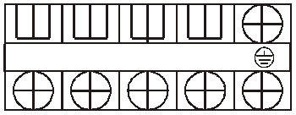

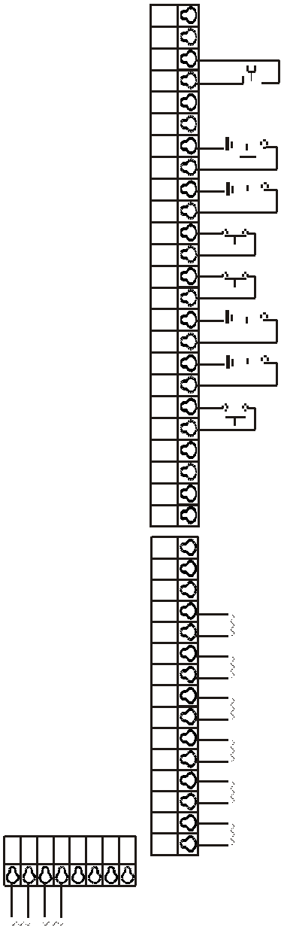

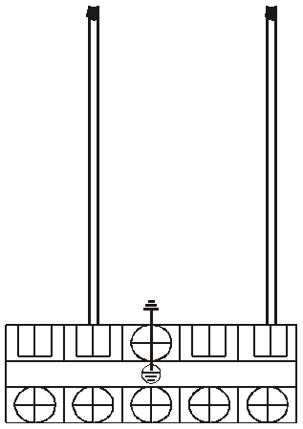

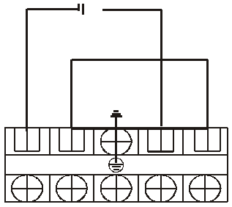

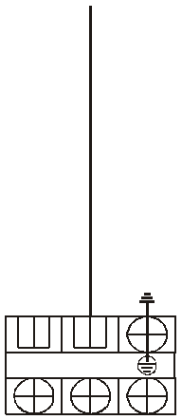

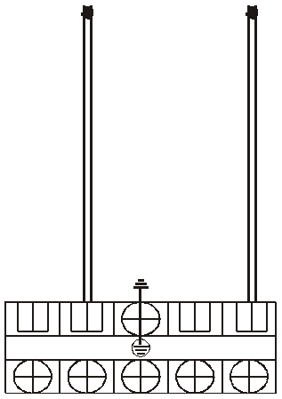

Outdoor fan

Three way valve

Power input

heater power input

heater power

power output

(air condition) pump pump power power output

power output

(380VAC/3PH/50Hz)

**Legend:**

: A.C.contactor/relay coil

output

power output

output

P3

: 4 way valve coil

HP1 LP1

:High pressure switch

:Low pressure switch

P4 : Power phase protection switch

: Compressor crankcase heater coil

KM1: Compressor A.C.contacto

KM2: Auxiliary electric heater A.C.contactorr

KA1 : Outdoor fan relay

KA2 : Hot water pump relay

KA3 : Floor heating(air condition) pump relay

KA4 : Water supply pump relay

CH1: Compressor crankcase heater

VA1: Four-way valve

FP1

SW1

SW2

SW3

SW4

SW5

:Hot water auxiliary electric heater overload protection switch

: Unit turn on/turn off switch(closed circuit)

: Model select switch

: Turn on/off auxiliary electric heater switch

(open circuit)

: Hot water side water flow switch

: Floor heating (air condition)side water flow switch

T1 T

T2 T T5 T T6 T T7 T

T8 T

T9 T

T10 T

: System coil temp.

: System discharge temp.

: Water supply return water temp.

: Outlet water temp.

: Inlet water temp.

: Solar collector temp.(5K resistance)

: Ambient t emp.

: Hot water tank temp.

VA2: EVI solenoid valve

SW6 : Floor heating(air heating/cooling) turn on/off switch(close circuit)

**4.3 Outdoor unit(**Mode:MAFP050A MAFP080A MAFP100A)

WIRING DIAGRAM (F03)

Orange Red

Orange Red

Capacitor Capacitor

Fan

Fan

Yellow/green

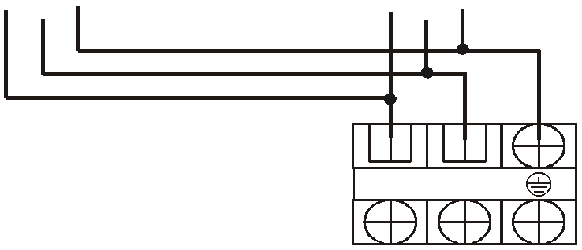

White

Black

L N

Coil sensor Ambient sensor

Power input

(220~240VAC)

CODE:MK3092-01 MK3092/MK3093

M A C O N

**AIR TO WATER HEAT PUMP**

Tel of Marketing Dept: +86-757-23669556

Tel of sales service Dept: +86-757-23669555

Fax: +86-757-23669554

Postal Code: 528322

Http:// [www.macon.com.cn](http://www.macon.com.cn)

[E-mail:sales@macon.com.cn](mailto:E-mail:sales@macon.com.cn)

Add No.12,Fuan 1 st Industrial Area, Leliu Town, Shunde District, Foshan City

Guangdong Province, China